Season after Pentecost – Proper 23 October 13, 2024 – 10:00 am
Welcome To Worship At Christ Church
You will see some people with masks and some without. Whatever your choice we respect and support your decision.
Please Note: The service may be recorded and broadcast across social media platforms, so by entering the sanctuary, you are giving permission to have your likeness shared as part of the service.

Hymnal 388 – O worship the King

The people standing, the Celebrant says
Blessed be the one, holy, and living God.
People Glory to God for ever and ever.
The Celebrant may say
Almighty God, to you all hearts are open, all desires known, and from you no secrets are hid: Cleanse the thoughts of our hearts by the inspiration of your Holy Spirit, that we may perfectly love you, and worthily magnify your holy Name; through Christ our Lord. Amen.
When appointed, the following hymn or some other song of praise is sung or said, all stand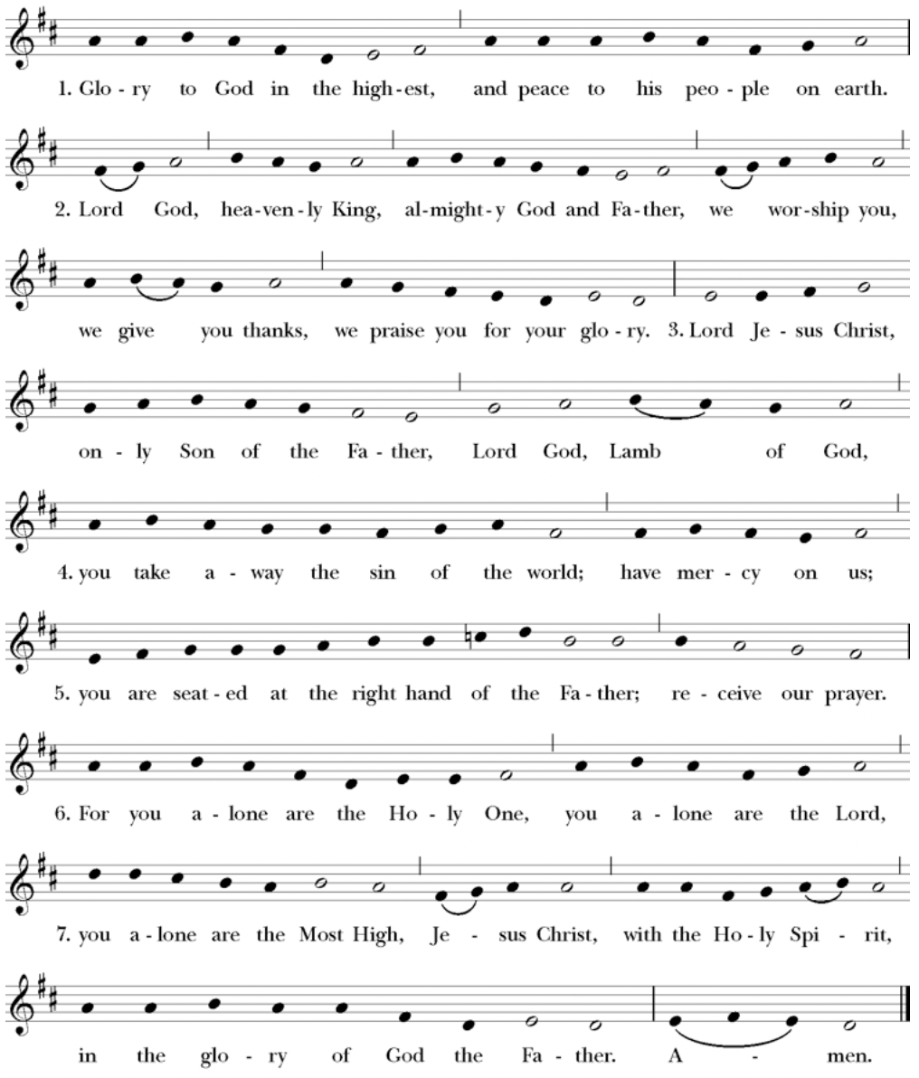
Setting: From New Plainsong; David Hurd (b. 1950)

The Collect of the Day
The Celebrant says to the people
The Lord be with you.
People And also with you.
Celebrant Let us pray.
Lord, we pray that your grace may always precede and follow us, that we may continually be given to good works; through Jesus Christ our Lord, who lives and reigns with you and the Holy Spirit, one God, now and for ever. Amen.
The Lessons
The people sit. One or two lessons, as appointed, are read, the Reader first saying
A Reading from the Prophet Amos (5:6-7,10-15)
Seek the Lord and live, or he will break out against the house of Joseph like fire, and it will devour Bethel, with no one to quench it. Ah, you that turn justice to wormwood, and bring righteousness to the ground! They hate the one who reproves in the gate, and they abhor the one who speaks the truth. Therefore, because you trample on the poor and take from them levies of grain, you have built houses of hewn stone, but you shall not live in them; you have planted pleasant vineyards, but you shall not drink their wine. For I know how many are your transgressions, and how great are your sins—you who afflict the righteous, who take a bribe, and push aside the needy in the gate. Therefore the prudent will keep silent in such a time; for it is an evil time. Seek good and not evil,
that you may live; and so the Lord, the God of hosts, will be with you,
just as you have said. Hate evil and love good, and establish justice in

the gate; it may be that the Lord, the God of hosts, will be gracious to the remnant of Joseph.
The Word of the Lord.
People Thanks be to God.
Silence may follow
psalm 90:12-17
12 So teach us to number our days *
that we may apply our hearts to wisdom.
13 Return, O Lord; how long will you tarry? *
be gracious to your servants.
14 Satisfy us by your loving-kindness in the morning; *
so shall we rejoice and be glad all the days of our life.
15 Make us glad by the measure of the days that you afflicted us *
and the years in which we suffered adversity.
16 Show your servants your works *
and your splendor to their children.
17 May the graciousness of the Lord our God be upon us; *
prosper the work of our hands;
prosper our handiwork.
Silence may follow.
A Reading from the letter to the Hebrews (4:12-16)
The word of God is living and active, sharper than any two-edged sword, piercing until it divides soul from spirit, joints from marrow; it is able to judge the thoughts and intentions of the heart. And before him no creature is hidden, but all are naked and laid bare to the eyes of the one to whom we must render an account. Since, then, we have a great high priest who has passed through the heavens, Jesus, the Son of God, let us hold fast to our confession. For we do not have a high priest who is unable to sympathize with our weaknesses, but we have one who in every respect has been tested as we are, yet without sin. Let us therefore approach the throne of grace with boldness, so that we may receive mercy and find grace to help in time of need.
The Word of the Lord
People Thanks be to God.
Hymnal 615 –Thy kingdom come

Deacon The Holy Gospel of our Lord Jesus Christ according to
Mark (10:17-31)
People Glory to you, Lord Christ
As Jesus was setting out on a journey, a man ran up and knelt before him, and asked him, “Good Teacher, what must I do to inherit eternal life?” Jesus said to him, “Why do you call me good? No one is good but God alone. You know the commandments: ‘You shall not murder; You shall not commit adultery; You shall not steal; You shall not bear false witness; You shall not defraud; Honor your father and mother.’” He said to him, “Teacher, I have kept all these since my youth.” Jesus, looking at him, loved him and said, “You lack one thing; go, sell what you own, and give the money to the poor, and you will have treasure in heaven; then come, follow me.” When he heard this, he was shocked and went away grieving, for he had many possessions. Then Jesus looked around and said to his disciples, “How hard it will be for those who have wealth to enter the kingdom of God!” And the disciples were perplexed at these words. But Jesus said to them again, “Children, how hard it is to enter the kingdom of God! It is easier for a camel to go through the eye of a needle than for someone who is rich to enter the kingdom of God.” They were greatly astounded and said to one another, “Then who can be saved?” Jesus looked at them and said, “For mortals it is impossible, but not for God; for God all things are possible.” Peter began to say to him, “Look, we have left everything and followed you.” Jesus said, “Truly I tell you, there is no one who has left house or brothers or sisters or mother or father or children or fields, for my sake and for the sake of the good news, who will not receive a hundredfold now in this age—houses, brothers and sisters, mothers and children, and fields

with persecutions—and in the age to come eternal life. But many who are first will be last, and the last will be first.”
After the Gospel, the Reader says
The Gospel of the Lord.
People Praise to you, Lord Christ
The Sermon The Rev. Mike Mayor
All standing
The Nicene Creed
We believe in one God,
the Father, the Almighty,
maker of heaven and earth,
of all that is, seen and unseen.
We believe in one Lord, Jesus Christ,
the only Son of God,
eternally begotten of the Father,
God from God, Light from Light,
true God from true God,
begotten, not made,
of one Being with the Father.
Through him all things were made.
For us and for our salvation
he came down from heaven:
by the power of the Holy Spirit
he became incarnate from the Virgin Mary,
and was made man.
For our sake he was crucified under Pontius Pilate;
he suffered death and was buried.
On the third day he rose again
in accordance with the Scriptures;
he ascended into heaven
and is seated at the right hand of the Father.
He will come again in glory to judge the living and the dead,
and his kingdom will have no end.
We believe in the Holy Spirit, the Lord, the giver of life,
who proceeds from the Father and the Son.
With the Father and the Son he is worshiped and glorified.
He has spoken through the Prophets.
We believe in one holy catholic and apostolic Church.
We acknowledge one baptism for the forgiveness of sins.
We look for the resurrection of the dead,
and the life of the world to come. Amen.
The Prayers of the People – Form VI
The Leader and People pray responsively
In peace, we pray to you, Lord God.
Silence
For all people in their daily life and work;
For our families, friends, and neighbors, and for those who are alone.
For this community, the nation, and the world;
For all who work for justice, freedom, and peace.
For the just and proper use of your creation;
For the victims of hunger, fear, injustice, and oppression.
For all who are in danger, sorrow, or any kind of trouble;
For those who minister to the sick, the friendless, and the needy.
For the peace and unity of the Church of God;
For all who proclaim the Gospel, and all who seek the Truth.
For Michael our Presiding Bishop; for Sean our Presiding Bishop-Elect; for Phil our Bishop; for Mike our Priest, for Linda our Deacon, and for all bishops and other ministers;
For all who serve God in his Church.
For the special needs and concerns of this congregation.
Silence
The People may add their own petitions
In our diocesan cycle of prayer, for St. Alban's, Edmonds; Redeemer, Kenmore; Christ Church, Seattle; and St. Andrew's, Seattle.
In our parish cycle of prayer, for Marti and Dugan, Alex, Stuart, Peter; Jeremy; Linda; and Tanya.
Hear us, Lord;
For your mercy is great.
We thank you, Lord, for all the blessings of this life.
Silence
The People may add their own thanksgivings
We will exalt you, O God our King;
And praise your Name for ever and ever.
We pray for all who have died, that they may have a place in your eternal kingdom.
Silence
The People may add their own petitions
Lord, let your loving-kindness be upon them;
Who put their trust in you.
We pray to you also for the forgiveness of our sins.
Silence may be kept.
Leader and People
Have mercy upon us, most merciful Father;
in your compassion forgive us our sins,
known and unknown,
things done and left undone;
and so uphold us by your Spirit
that we may live and serve you in newness of life,
to the honor and glory of your Name;
through Jesus Christ our Lord. Amen.
The Celebrant concludes with an absolution or a suitable Collect.
The Peace
All stand. The Celebrant says to the people
The peace of Christ be always with you.
People And also with you.
Then the Ministers and People may greet one another in the name of the Lord.
Offertory Hymnal 707 – Take my life

Doxology
The Great Thanksgiving
The people remain standing. The Celebrant, whether bishop or priest, faces them and sings or says
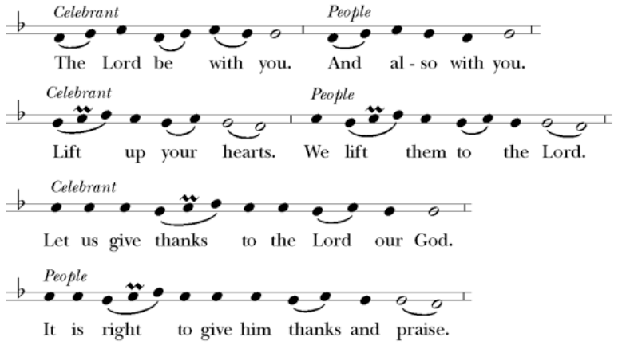
Then, facing the Holy Table, the Celebrant proceeds
It is truly right, and good and joyful, to give you thanks all holy God, source of life and fountain of mercy. You have filled us and all creation with your blessing and fed us with your constant love; you have redeemed us in Jesus Christ and knit us into one body. Through your Spirit you replenish us and call us to fullness of life. Therefore, joining with Angels and Archangels and with the faithful of every generation, we lift our voices with all creation as we sing:

Celebrant and People
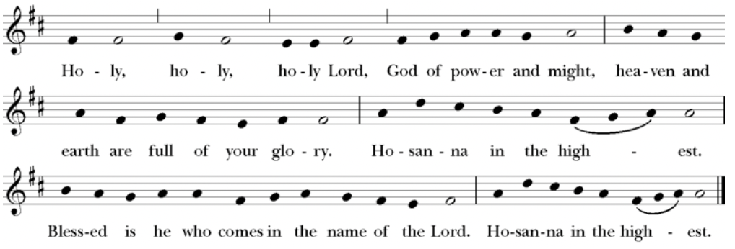
Music: From New Plainsong; David Hurd (b. 1950)
The Celebrant continues
Blessed are you, gracious God, creator of the universe and giver of life. You formed us in your own image and called us to dwell in your infinite love.
You gave the world into our care that we might be your faithful stewards and show forth your bountiful grace.
But we failed to honor your image in one another and in ourselves; we would not see your goodness in the world around us; and so we violated your creation, abused one another, and rejected your love. Yet you never ceased to care for us, and prepared the way of salvation for all people.
Through Abraham and Sarah you called us into covenant with you. You delivered us from slavery, sustained us in the wilderness, and raised up prophets to renew your promise of salvation. Then, in the fullness of time, you sent your eternal Word, made mortal flesh in Jesus. Born into the human family, and dwelling among us, he revealed your glory. Giving himself freely to death on the cross, he triumphed over evil, opening the way of freedom and life.
At the following words concerning the bread, the Celebrant is to hold it, or lay a hand upon it; and at the words concerning the cup, to hold or place a hand upon the cup and any other vessel containing wine to be consecrated.
On the night before he died for us, Our Savior Jesus Christ took bread, and when he had given thanks to you, he broke it, and gave it to his friends, and said: “Take, eat: This is my Body which is given for you. Do this for the remembrance of me.”
As supper was ending, Jesus took the cup of wine, and when he had given thanks, he gave it to them, and said: “Drink this, all of you: This is my Blood of the new Covenant, which is poured out for you and for all for the forgiveness of sins. Whenever you drink it, do this for the remembrance of me.”
Therefore we proclaim the mystery of faith:
Celebrant and People
Christ has died.
Christ is risen.
Christ will come again.
The Celebrant continues
Remembering his death and resurrection, we now present to you from your creation this bread and this wine. By your Holy Spirit may they be for us the Body and Blood of our Savior Jesus Christ. Grant that we who share these gifts may be filled with the Holy Spirit and live as Christ’s Body in the world. Bring us into the everlasting heritage of your daughters and sons, that with all your saints, past, present, and yet to come, we may praise your Name for ever.

Through Christ and with Christ and in Christ, in the unity of the Holy Spirit, to you be honor, glory, and praise, for ever and ever.
People
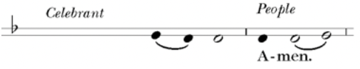
Celebrant
As our Savior Christ
has taught us,
we now pray,

People and Celebrant
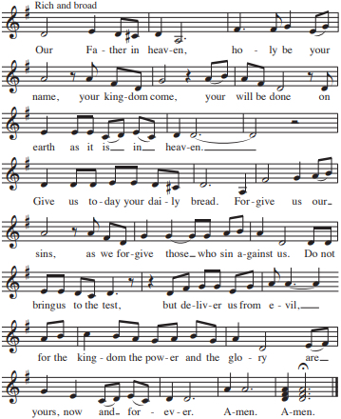
The Breaking of the Bread
The Celebrant breaks the consecrated Bread.
A period of silence is kept.
Then may be sung or said
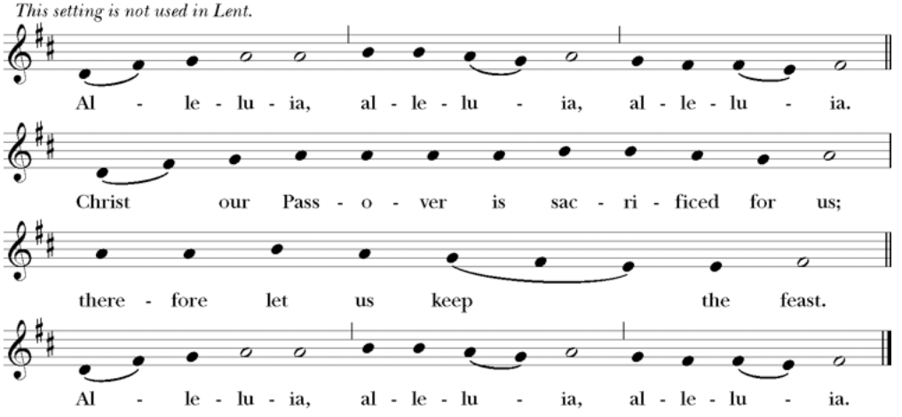
Music: From New Plainsong; David Hurd (b. 1950)
Facing the people, the Celebrant says the following Invitation
The Gifts of God for the People of God.
and may add Take them in remembrance that Christ died for
you, and feed on him in your hearts by faith,
with thanksgiving.
The priest immediately delivers the Sacrament to the people.
The Bread is given to the communicants with these words
The Body of Christ, the bread of heaven. [Amen.]
The Blood of Christ, the cup of salvation. [Amen.]
Hymnal 475 – God himself is with us
After communion the Celebrant says
Let us pray.
Celebrant and People
God of abundance,
you have fed us
with the bread of life and cup of salvation;
you have united us
with Christ and one another;
and you have made us one
with all your people in heaven and on earth.
Now send us forth
in the power of your Spirit,
that we may proclaim your redeeming love to the world
and continue for ever
in the risen life of Christ our Savior. Amen.
The Bishop when present, or the Priest, may bless the people.
Hymnal 655 – O Jesus, I have promised

Deacon Let us go forth into the world
rejoicing in the power of the Spirit.
People Thanks be to God.
Postlude
Announcements
Flowers for this Sunday
The flowers for this Sunday, October 13, 2024, are given by Peggy Wheeler to the Glory of God and gratefully for family and celebrating the birthdays Connie, Sue and Autumn.
Let's Talk About God
Let's Talk About God, our informal conversation about matters of faith, will meet today, during the coffee hour following the 10 am service. All are welcome to come and participate. We will have one more session on October 27 before concluding for the year.
Sleeping Bag Ingathering
Sleeping Bag Ingathering is today.
Heartfelt thanks to everyone who donated a sleeping bag or cash towards the purchase of a sleeping bag.
Every sleeping bag we collect makes a difference in someone's life. A sleeping bag can mean the difference between life and death. It can offer warmth in the winter and a little cushion for the summer.
Thank you for making a difference to someone in need.
Reminder - Vestry Meeting on October 15
﻿Just a friendly reminder that the next Vestry meeting is on Tuesday, October 15 at 6:00 pm via Zoom.
To connect via Zoom use the following:
Meeting ID: 876 7929 5051
Passcode: 774010
Spaghetti Dinner
Save space on your calendar for our annual spaghetti dinner & fellowship gathering in the parish hall this Saturday, October 19 starting at 5:30 pm.
It will be an opportunity to gather, spend time in community, and to hear information on our fall stewardship campaign.
A sign-up sheet is available in the parish hall for contributions to this fun event!
Time for the Women's Fall Retreat!! October 25-27
Faith, food, and fun
Rest, relax, refresh
All this and more at the annual Women’s retreat at St Andrews House Retreat Center on Hood Canal in Union WA. The focus this year will be on the activist and poet the St. Rev. Dr. Pauli Murray.
Anna Pauline "Pauli" Murray was an American civil rights activist, advocate, legal scholar and theorist, author and – later in life – an Episcopal priest. Murray's work influenced the civil rights movement and expanded legal protection for gender equality.
Your leaders for this fun-filled weekend are Barb Johnsey and Maria Haack.
The Registration forms will be in the Parish Hall starting this Sunday, Sept 1st, 2024. FINAL REGISTRATION DEADLINE IS TODAY.
Accommodations:
25 beds Total (5 of them top bunks)
NOTE: 4 - first floor ADA accessible beds are available.
Cost for weekend is $250/person.
Scholarship help is available. See either Maria or Melinda.
St. Andrews House Retreat Center https://www.saintandrewshouse.org/
Fellowship Book Group
Please join us for fellowship and lively discussion. We start with fellowship at 6:00 pm and discussion starts at 6:30 pm. We’d love to have you join us.
The next meeting will be on our usual meeting day, (4th Monday of the month) October 28, 2024, via zoom. The Zoom link and passcode are:
Meeting ID: 828 2655 0583
Passcode: 121698
The book for October 28th will be "The Color of Water: A Black Man's Tribute to His White Mother" by James McBride.
(Found at various discount stores, Kindle, Audible, paperback)
From the bestselling author of Deacon King Kong and the National Book Award-winning The Good Lord Bird: The modern classic that spent more than two years on The New York Times bestseller list and that Oprah.com calls one of the best memoirs of a generation,
Who is Ruth McBride Jordan? A self-declared "light-skinned" woman evasive about her ethnicity, yet steadfast in her love for her twelve black children. James McBride, journalist, musician, and son, explores his mother's past, as well as his own upbringing and heritage, in a poignant and powerful debut, The Color Of Water: A Black Man's Tribute to His White Mother. The son of a black minister and a woman who would not admit she was white, James McBride grew up in "orchestrated chaos" with his eleven siblings in the poor, all-black projects of Red Hook, Brooklyn. "Mommy," a fiercely protective woman with "dark eyes full of pep and fire," herded her brood to Manhattan's free cultural events, sent them off on buses to the best (and mainly Jewish) schools, demanded good grades, and commanded respect. As a young man, McBride saw his mother as a source of embarrassment, worry, and confusion—and reached thirty before he began to discover the truth about her early life and long-buried pain.
In The Color of Water, McBride retraces his mother's footsteps and, through her searing and spirited voice, recreates her remarkable story. The daughter of a failed itinerant Orthodox rabbi, she was born Rachel Shilsky (actually Ruchel Dwara Zylska) in Poland on April 1, 1921. Fleeing pogroms, her family emigrated to America and ultimately settled in Suffolk, Virginia, a small town where anti-Semitism and racial tensions ran high. With candor and immediacy, Ruth describes her parents' loveless marriage; her fragile, handicapped mother; her cruel, sexually-abusive father; and the rest of the family and life she abandoned.
At seventeen, after fleeing Virginia and settling in New York City, Ruth married a black minister and founded the all- black New Brown Memorial Baptist Church in her Red Hook living room. "God is the color of water," Ruth McBride taught her children, firmly convinced that life's blessings and life's values transcend race. Twice widowed, and continually confronting overwhelming adversity and racism, Ruth's determination, drive and discipline saw her dozen children through college—and most through graduate school. At age 65, she herself received a degree in social work from Temple University.
Interspersed throughout his mother's compelling narrative, McBride shares candid recollections of his own experiences as a mixed-race child of poverty, his flirtations with drugs and violence, and his eventual self- realization and professional success. The Color of Water touches readers of all colors as a vivid portrait of growing up, a haunting meditation on race and identity, and a lyrical valentine to a mother from her son.
Questions? Speak with any of the following: Shelly Fairbanks, DeeDee Fournier, Sandi Carter, Jen Killion, Melinda Jackson
Santa’s Seconds
Can you believe how fast this year seems to be flying by? In just eleven weeks we will be holding the Annual Santa's Second Sale on December 7th. That means now is the time to go through your house, garage, storage unit, etc. and look for items that can be donated to the sale. Remember no clothing, electronics, or luggage please. Items that are in good condition for gifting are what we need. Toys, books, household goods, jewelry, and seasonal decor are good sellers. You can bring your donations to the stage. If you can, please put a price on the items.
The funds raised go to support local charitable organizations and the deposit and scholarship help for the annual Women's Retreat.
Ministry Moment - Finance
The Finance Ministry is vital to the operating functions of our parish.
Our current committee is made up of volunteers and Fr. Mike. We meet monthly to review the financial statements that are created out of the information that our bookkeeper enters into Church Windows.
We monitor the invoices, bills, and vouchers that come through to ensure their accuracy and timelines.
We work with the counters and altar guild when money is physically handled.
We work with the treasurer on recommendations for the vestry concerning some money matters/management.
We make recommendations for the budget process to the vestry.
On an annual basis, we complete an audit based upon Diocesan requirements in conjunction with another church within our Diocese. The results of the audit is reviewed by the Vestry and is submitted to the Diocese for their review.
Thank you for your support of all of our ministries. If you would like further information, please contact Christine Scholer, Ruth Pitingoro, Susan Meyers, Jane Beck, Melinda Jackson, or Fr. Mike.
Puyallup Food Bank
Thank you! Thank you! Thank you All!
This past month the baskets in the parish hall have been filled to the brim with donations for the food bank.
So wonderful! Well done Everyone!!
Now it is October, or as some like to say, " Candy month". What are some special things that are shelf stable that families can use and also be fun for the young & young at heart? Here are a few ideas:
- Instant coffee, tea. Maybe pumpkin spice flavored?
- Instant hot cocoa, apple cider
- Sweet things for dessert
- Bag of candy to give out to trick or treaters
- Fun napkins
As always, any monies you would like to give for the Food Bank can be marked as such and put in the collection plate, or perhaps mailed to the church.
﻿Thank you for all you do to help out our neighbors. Also give them a smile and hope for better days. :)
Judy Hansen/Vestry Outreach
Soup Kitchen
Thank you to all the volunteers: Nancy N. for providing the soup and bread; Susan M. for fruit; Steve A. for Juice; and Calvin S. and Rolin S. for serving the guests, and Lynn S, for serving at the Hospitality Table.
We are in need of a volunteer to provide soup next Wednesday, Oct. 16. Please contact Susan M. or Deacon Linda if you can provide soup.
There is a sign up form on the round table by the Sanctuary door in the parish hall for volunteers to sign up to provide food or to serve.
This week’s totals:
- People served: 14
- Bus passes given out: 9
- Laundry Packets given out: 18
- How many picked up mail: 8
- Toiletries given out: 14
- Socks given away: 9
Hospitality/Toiletry Items Needed:
Chap stick, and Body Lotion
We are in need of some cans of basic soup we can keep on hand for back up. We need cans of Chicken Noodle Soup, Vegetable soup, Tomato soup, Vegetable Beef soup, etc.
Donations of food can be brought in on Sunday mornings or on Wednesdays before 10:00 am. If you come on a Wednesday morning please ring the doorbell and Deacon Linda will let you in.
Thank you for your support of this ministry to feed those in need.
Prayers and Peace,
Deacon Linda
Sermon Notes

Today's Ministers of Worship:
Celebrant: The Rev. Mike Mayor
Deacon: The Rev. Linda Potter
Lectors: Sue Golden, Carla Golden
Acolyte: Rolin Stone
Eucharistic Minister: David Steere
Pianist: Vicki Melton
Usher: Tanya Elder
Greeters: Carla Golden, Christine Scholer
Closers: Barry and Kris O’Brien
Altar Guild: Peggy Wheeler, Rolin Stone, Sue Golden, Carla Golden
Music permission through OneLicense #A-706918

Scan to give online. All payments are processed through Paypal.
Christ Episcopal Church
A congregation of the Episcopal Diocese of Olympia
Bishop – The Rt. Rev. Philip N. LaBelle
Rector – The Rev. Mike Mayor
Vestry
Sr. Warden – Sue Golden
Jr. Warden for Property – Sean Williams
Jr. Warden for Communication – Nancy Nesheim
Treasurer – Melinda Jackson
Clerk – Tanya Elder
Member – Maria Haack
Member – Judy Hansen
Member – John Hopkins
Member – Kathy Mason
Member – Susan Myers
210 5th St. SW | Puyallup, WA | 98371
253-848-2323 | office@episcopallup.com
www.episcopallup.com

