Season after Pentecost – Proper 24 October 20, 2024 – 10:00 am
Welcome To Worship At Christ Church
You will see some people with masks and some without. Whatever your choice we respect and support your decision.
Please Note: The service may be recorded and broadcast across social media platforms, so by entering the sanctuary, you are giving permission to have your likeness shared as part of the service.

Hymnal 517 – How lovely is thy dwelling
The people standing, the Celebrant says
Blessed be the one, holy, and living God.
People Glory to God for ever and ever.
The Celebrant may say
Almighty God, to you all hearts are open, all desires known, and from you no secrets are hid: Cleanse the thoughts of our hearts by the inspiration of your Holy Spirit, that we may perfectly love you, and worthily magnify your holy Name; through Christ our Lord. Amen.

When appointed, the following hymn or some other song of praise is sung or said, all stand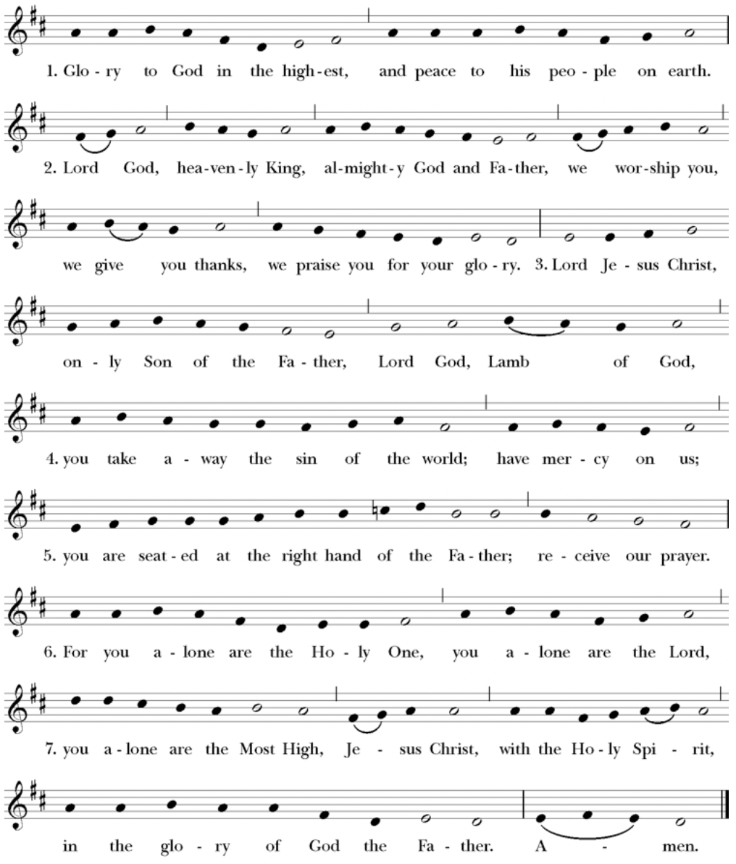
Setting: From New Plainsong; David Hurd (b. 1950)

The Collect of the Day
The Celebrant says to the people
The Lord be with you.
People And also with you.
Celebrant Let us pray.
Almighty and everlasting God, in Christ you have revealed your glory among the nations: Preserve the works of your mercy, that your Church throughout the world may persevere with steadfast faith in the confession of your Name; through Jesus Christ our Lord, who lives and reigns with you and the Holy Spirit, one God, for ever and ever. Amen.
The Lessons
The people sit. One or two lessons, as appointed, are read, the Reader first saying
A Reading from the Prophet Isaiah (53:4-12)
Surely he has borne our infirmities and carried our diseases; yet we accounted him stricken, struck down by God, and afflicted. But he was wounded for our transgressions, crushed for our iniquities; upon him was the punishment that made us whole, and by his bruises we are healed. All we like sheep have gone astray; we have all turned to our own way, and the Lord has laid on him the iniquity of us all. He was oppressed, and he was afflicted, yet he did not open his mouth; like a lamb that is led to the slaughter, and like a sheep that before its shearers is silent, so he did not open his mouth. By a perversion of justice he was taken away. Who could have imagined his future? For he was cut off from the land of the living, stricken for the transgression of my people. They made his grave with the wicked and his tomb with the rich, although he had done no violence, and there was no deceit in his mouth. Yet it was the will of the Lord to crush him with pain. When you make his life an offering for sin, he shall see his offspring, and shall prolong his days; through him the will of the Lord shall prosper. Out of his anguish he shall see light; he shall find satisfaction through his knowledge. The righteous one, my servant, shall make many righteous, and he shall bear their iniquities. Therefore I will allot him a portion with the great, and he shall divide the spoil with the strong; because he poured out himself to death, and was numbered with the transgressors; yet he bore the sin of many, and made intercession for the transgressors.
The Word of the Lord.
People Thanks be to God.
Silence may follow
psalm 91:9-16
9 Because you have made the Lord your refuge, *
and the Most High your habitation,
10 There shall no evil happen to you, *
neither shall any plague come near your dwelling.
11 For he shall give his angels charge over you, *
to keep you in all your ways.
12 They shall bear you in their hands, *
lest you dash your foot against a stone.
13 You shall tread upon the lion and adder; *
you shall trample the young lion and the serpent under your feet.
14 Because he is bound to me in love,
therefore will I deliver him; *
I will protect him, because he knows my Name.
15 He shall call upon me, and I will answer him; *
I am with him in trouble;
I will rescue him and bring him to honor.
16 With long life will I satisfy him, *
and show him my salvation.
Silence may follow.
A Reading from the letter to the Hebrews 5:1-10)
Every high priest chosen from among mortals is put in charge of things pertaining to God on their behalf, to offer gifts and sacrifices for sins. He is able to deal gently with the ignorant and wayward, since he himself is subject to weakness; and because of this he must offer sacrifice for his own sins as well as for those of the people. And one does not presume to take this honor, but takes it only when called by God, just as Aaron was. So also Christ did not glorify himself in becoming a high priest, but was appointed by the one who said to him, “You are my Son, today I have begotten you”; as he says also in another place, “You are a priest forever, according to the order of Melchizedek.” In the days of his flesh, Jesus offered up prayers and supplications, with loud cries and tears, to the one who was able to save him from death, and he was heard because of his reverent submission. Although he was a Son, he learned obedience through what he suffered; and having been made perfect, he became the source of eternal salvation for all who obey him, having been designated by God a high priest according to the order of Melchizedek.
The Word of the Lord
People Thanks be to God.

Hymnal 455 –O love of God

Deacon The Holy Gospel of our Lord Jesus Christ according to
Mark (10:35-45)
People Glory to you, Lord Christ
James and John, the sons of Zebedee, came forward to Jesus and said to him, “Teacher, we want you to do for us whatever we ask of you.” And he said to them, “What is it you want me to do for you?” And they said to him, “Grant us to sit, one at your right hand and one at your left, in your glory.” But Jesus said to them, “You do not know what you are asking. Are you able to drink the cup that I drink, or be baptized with the baptism that I am baptized with?” They replied, “We are able.” Then Jesus said to them, “The cup that I drink you will drink; and with the baptism with which I am baptized, you will be baptized; but to sit at my right hand or at my left is not mine to grant, but it is for those for whom it has been prepared.” When the ten heard this, they began to be angry with James and John. So Jesus called them and said to them, “You know that among the Gentiles those whom they recognize as their rulers lord it over them, and their great ones are tyrants over them. But it is not so among you; but whoever wishes to become great among you must be your servant, and whoever wishes to be first among you must be slave of all. For the Son of Man came not to be served but to serve, and to give his life a ransom for many.”
After the Gospel, the Reader says
The Gospel of the Lord.
People Praise to you, Lord Christ
The Sermon The Rev. Mike Mayor
All standing
The Nicene Creed
We believe in one God,
the Father, the Almighty,
maker of heaven and earth,
of all that is, seen and unseen.
We believe in one Lord, Jesus Christ,
the only Son of God,
eternally begotten of the Father,
God from God, Light from Light,
true God from true God,
begotten, not made,
of one Being with the Father.
Through him all things were made.
For us and for our salvation
he came down from heaven:
by the power of the Holy Spirit
he became incarnate from the Virgin Mary,
and was made man.
For our sake he was crucified under Pontius Pilate;
he suffered death and was buried.
On the third day he rose again
in accordance with the Scriptures;
he ascended into heaven
and is seated at the right hand of the Father.
He will come again in glory to judge the living and the dead,
and his kingdom will have no end.
We believe in the Holy Spirit, the Lord, the giver of life,
who proceeds from the Father and the Son.
With the Father and the Son he is worshiped and glorified.
He has spoken through the Prophets.
We believe in one holy catholic and apostolic Church.
We acknowledge one baptism for the forgiveness of sins.
We look for the resurrection of the dead,
and the life of the world to come. Amen.
The Prayers of the People – Form VI
The Leader and People pray responsively
In peace, we pray to you, Lord God.
Silence
For all people in their daily life and work;
For our families, friends, and neighbors, and for those who are alone.
For this community, the nation, and the world;
For all who work for justice, freedom, and peace.
For the just and proper use of your creation;
For the victims of hunger, fear, injustice, and oppression.
For all who are in danger, sorrow, or any kind of trouble;
For those who minister to the sick, the friendless, and the needy.
For the peace and unity of the Church of God;
For all who proclaim the Gospel, and all who seek the Truth.
For Michael our Presiding Bishop; for Sean our Presiding Bishop-Elect; for Phil our Bishop; for Mike our Priest, for Linda our Deacon, and for all bishops and other ministers;
For all who serve God in his Church.
For the special needs and concerns of this congregation.
Silence
The People may add their own petitions
In our diocesan cycle of prayer, for St. Luke’s, Seattle; St. Stephen’s, Seattle.
In our parish cycle of prayer, for Shelly, Kay, Diane, DeeDee, Linda & Scott.
Hear us, Lord;
For your mercy is great.
We thank you, Lord, for all the blessings of this life.
Silence
The People may add their own thanksgivings
We will exalt you, O God our King;
And praise your Name for ever and ever.

We pray for all who have died, that they may have a place in your eternal kingdom.
Silence
The People may add their own petitions
Lord, let your loving-kindness be upon them;
Who put their trust in you.
We pray to you also for the forgiveness of our sins.
Silence may be kept.
Leader and People
Have mercy upon us, most merciful Father;
in your compassion forgive us our sins,
known and unknown,
things done and left undone;
and so uphold us by your Spirit
that we may live and serve you in newness of life,
to the honor and glory of your Name;
through Jesus Christ our Lord. Amen.
The Celebrant concludes with an absolution or a suitable Collect.
The Peace
All stand. The Celebrant says to the people
The peace of Christ be always with you.
People And also with you.
Then the Ministers and People may greet one another in the name of the Lord.
Offertory Hymnal 479 – Glory be to Jesus

Doxology

The Great Thanksgiving
The people remain standing. The Celebrant, whether bishop or priest, faces them and sings or says
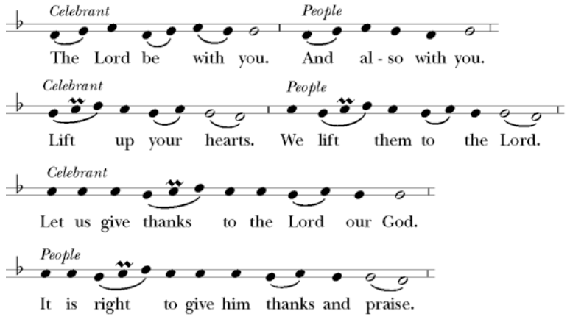
Then, facing the Holy Table, the Celebrant proceeds
It is truly right, and good and joyful, to give you thanks all holy God, source of life and fountain of mercy. You have filled us and all creation with your blessing and fed us with your constant love; you have redeemed us in Jesus Christ and knit us into one body. Through your Spirit you replenish us and call us to fullness of life. Therefore, joining with Angels and Archangels and with the faithful of every generation, we lift our voices with all creation as we sing:
Celebrant and People
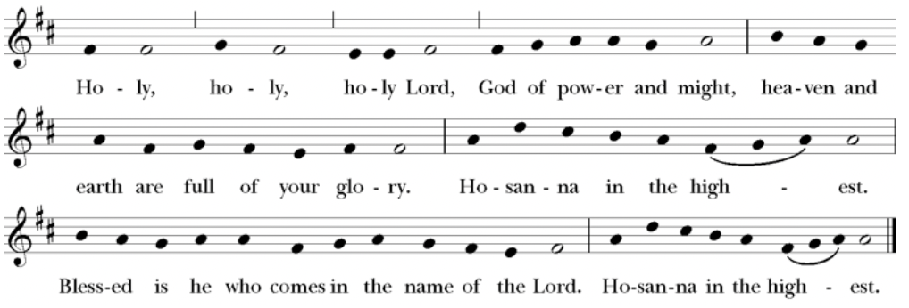
Music: From New Plainsong; David Hurd (b. 1950)
The Celebrant continues
Blessed are you, gracious God, creator of the universe and giver of life. You formed us in your own image and called us to dwell in your infinite love.
You gave the world into our care that we might be your faithful stewards and show forth your bountiful grace.
But we failed to honor your image in one another and in ourselves; we would not see your goodness in the world around us; and so we violated your creation, abused one another, and rejected your love. Yet you never ceased to care for us, and prepared the way of salvation for all people.
Through Abraham and Sarah you called us into covenant with you. You delivered us from slavery, sustained us in the wilderness, and raised up prophets to renew your promise of salvation. Then, in the fullness of time, you sent your eternal Word, made mortal flesh in Jesus. Born into the human family, and dwelling among us, he revealed your glory. Giving himself freely to death on the cross, he triumphed over evil, opening the way of freedom and life.
At the following words concerning the bread, the Celebrant is to hold it, or lay a hand upon it; and at the words concerning the cup, to hold or place a hand upon the cup and any other vessel containing wine to be consecrated.
On the night before he died for us, Our Savior Jesus Christ took bread, and when he had given thanks to you, he broke it, and gave it to his friends, and said: “Take, eat: This is my Body which is given for you. Do this for the remembrance of me.”
As supper was ending, Jesus took the cup of wine, and when he had given thanks, he gave it to them, and said: “Drink this, all of you: This is my Blood of the new Covenant, which is poured out for you and for all for the forgiveness of sins. Whenever you drink it, do this for the remembrance of me.” Therefore we proclaim the mystery of faith:
Celebrant and People
Christ has died.
Christ is risen.
Christ will come again.
The Celebrant continues
Remembering his death and resurrection, we now present to you from your creation this bread and this wine. By your Holy Spirit may they be for us the Body and Blood of our Savior Jesus Christ. Grant that we who share these gifts may be filled with the Holy Spirit and live as Christ’s Body in the world. Bring us into the everlasting heritage of your daughters and sons, that with all your saints, past, present, and yet to come, we may praise your Name for ever.
Through Christ and with Christ and in Christ, in the unity of the Holy Spirit, to you be honor, glory, and praise, for ever and ever.
People
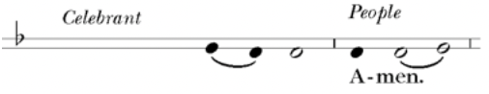
Celebrant
As our Savior Christ
has taught us,
we now pray,

People and Celebrant
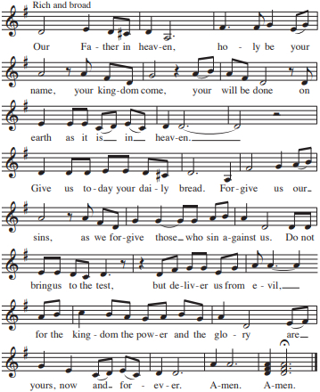
The Breaking of the Bread
The Celebrant breaks the consecrated Bread.
A period of silence is kept.
Then may be sung or said
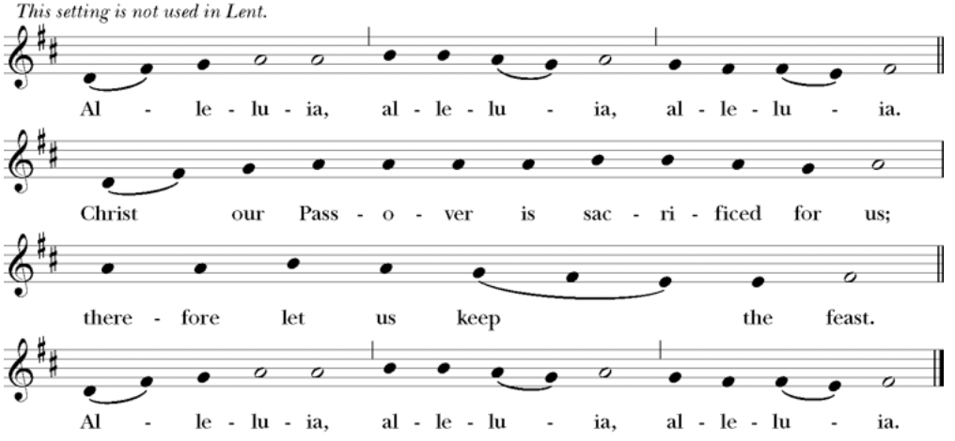
Music: From New Plainsong; David Hurd (b. 1950)
Facing the people, the Celebrant says the following Invitation
The Gifts of God for the People of God.
and may add Take them in remembrance that Christ died for
you, and feed on him in your hearts by faith,
with thanksgiving.
The priest immediately delivers the Sacrament to the people.
The Bread is given to the communicants with these words
The Body of Christ, the bread of heaven. [Amen.]
The Blood of Christ, the cup of salvation. [Amen.]
Hymnal 811 – Be not afraid
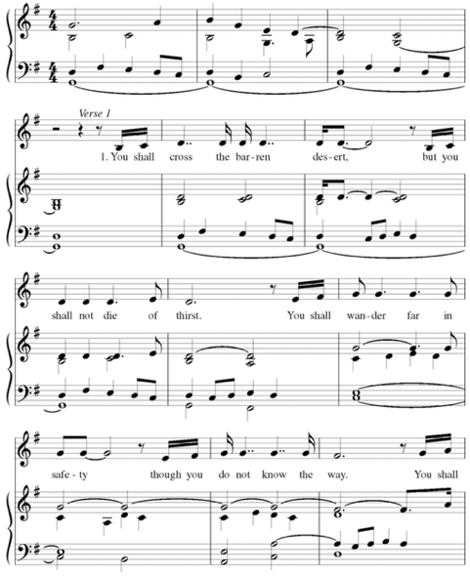
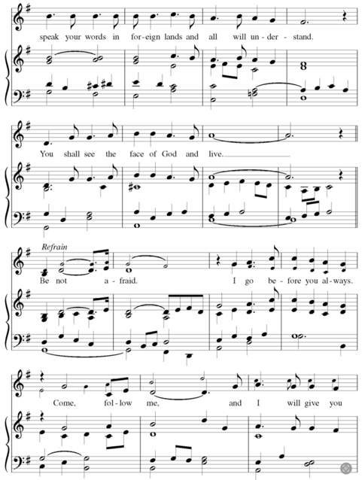
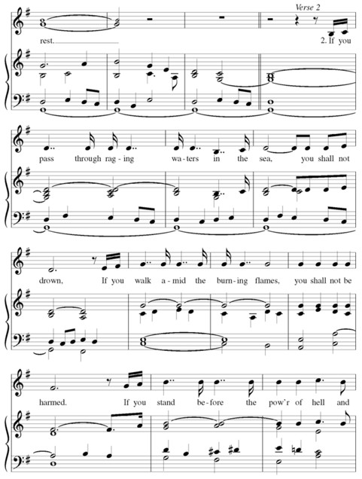
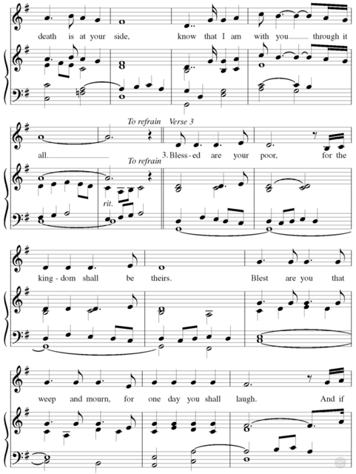
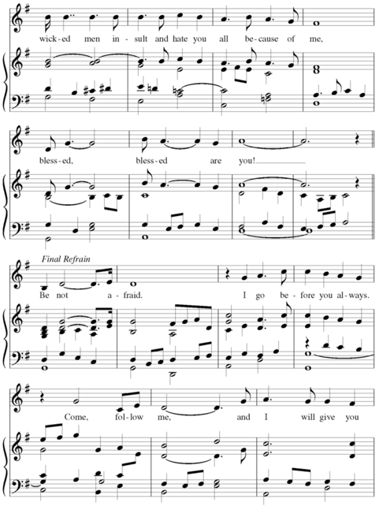
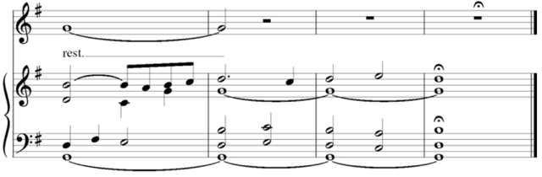
Author: Bob Dufford © 1975, 1978, Robert J. Dufford, SJ, and OCP Publications
After communion the Celebrant says
Let us pray.
Celebrant and People
God of abundance,
you have fed us
with the bread of life and cup of salvation;
you have united us
with Christ and one another;
and you have made us one
with all your people in heaven and on earth.
Now send us forth
in the power of your Spirit,
that we may proclaim your redeeming love to the world
and continue for ever
in the risen life of Christ our Savior. Amen.
The Bishop when present, or the Priest, may bless the people.

Hymnal 477 – all praise to thee

Deacon Let us go forth into the world
rejoicing in the power of the Spirit.
People Thanks be to God.
Postlude

Announcements
Flowers for this Sunday
The flowers for this Sunday, October 20, 2024, are given to the Glory of God by Terry Grundy honoring the birthdays of her daughter Katie and her grandson Cameron.
Nursery and Sunday School
Please note that the Nursery and Children's Church School will not be available on Sunday, October 27, 2024.
Let’s Talk About God
Let's Talk About God, our informal conversation about matters of faith, will meet for the last time this year on Sunday, October 27, during the coffee hour following the 10 am service. All are welcome to come and participate.
Fellowship Book Group
Please join us for fellowship and lively discussion. We start with fellowship at 6:00 pm and discussion starts at 6:30 pm. We’d love to have you join us.
The next meeting will be on our usual meeting day, (4th Monday of the month) October 28, 2024, via zoom. The Zoom link and passcode are:
Meeting ID: 828 2655 0583
Passcode: 121698
The book for October 28th will be "The Color of Water: A Black Man's Tribute to His White Mother" by James McBride.
(Found at various discount stores, Kindle, Audible, paperback)
From the bestselling author of Deacon King Kong and the National Book Award-winning The Good Lord Bird: The modern classic that spent more than two years on The New York Times bestseller list and that Oprah.com calls one of the best memoirs of a generation,
Who is Ruth McBride Jordan? A self-declared "light-skinned" woman evasive about her ethnicity, yet steadfast in her love for her twelve black children. James McBride, journalist, musician, and son, explores his mother's past, as well as his own upbringing and heritage, in a poignant and powerful debut, The Color Of Water: A Black Man's Tribute to His White Mother. The son of a black minister and a woman who would not admit she was white, James McBride grew up in "orchestrated chaos" with his eleven siblings in the poor, all-black projects of Red Hook, Brooklyn. "Mommy," a fiercely protective woman with "dark eyes full of pep and fire," herded her brood to Manhattan's free cultural events, sent them off on buses to the best (and mainly Jewish) schools, demanded good grades, and commanded respect. As a young man, McBride saw his mother as a source of embarrassment, worry, and confusion—and reached thirty before he began to discover the truth about her early life and long-buried pain.
In The Color of Water, McBride retraces his mother's footsteps and, through her searing and spirited voice, recreates her remarkable story. The daughter of a failed itinerant Orthodox rabbi, she was born Rachel Shilsky (actually Ruchel Dwara Zylska) in Poland on April 1, 1921. Fleeing pogroms, her family emigrated to America and ultimately settled in Suffolk, Virginia, a small town where anti-Semitism and racial tensions ran high. With candor and immediacy, Ruth describes her parents' loveless marriage; her fragile, handicapped mother; her cruel, sexually-abusive father; and the rest of the family and life she abandoned.
At seventeen, after fleeing Virginia and settling in New York City, Ruth married a black minister and founded the all- black New Brown Memorial Baptist Church in her Red Hook living room. "God is the color of water," Ruth McBride taught her children, firmly convinced that life's blessings and life's values transcend race. Twice widowed, and continually confronting overwhelming adversity and racism, Ruth's determination, drive and discipline saw her dozen children through college—and most through graduate school. At age 65, she herself received a degree in social work from Temple University.
Interspersed throughout his mother's compelling narrative, McBride shares candid recollections of his own experiences as a mixed-race child of poverty, his flirtations with drugs and violence, and his eventual self- realization and professional success. The Color of Water touches readers of all colors as a vivid portrait of growing up, a haunting meditation on race and identity, and a lyrical valentine to a mother from her son.
Questions? Speak with any of the following: Shelly Fairbanks, DeeDee Fournier, Sandi Carter, Jen Killion, Melinda Jackson
Knit Hats and Ditty Bags
Deacon Linda and Judy Hansen, Vestry Liaison for Outreach
On Sunday, November 17, will be the ingathering of knit hats and ditty bags. Fr. Mike will bless the knit hats and Ditty Bags at both the 8 and 10 am church services. Rich Shively, Executive Director of Seattle Seafarers Center, will be with us on that Sunday. In his sermon last year, Mr. Shively said, "We are called to meet Christ in those in need. We are called to look outward. The things we do are an extension of God's love. It is little things we do in life that matter. Making knit hats and stitching ditty bags is not a little thing!"
For the past four years, each November, Christ Church has collected knit hats and ditty bags and donated them to the Seattle Seafarers Ministry. Our ingathering makes a difference in the lives of Seafarers of all ages and nationalities. They work an average of 80 hours a week (plus overtime) to bring us necessary goods. The knit hats and ditty bags are given as gifts to the seaman who work on the cargo ships that come into Seattle. These are treasured items to them and will travel all over the world as the seafarers wear their hats to protect themselves from the bad weather they encounter.
If you are interested in making a knit hat or a ditty bag the pattern is on
https://www.mts-seattle.org/knit-or-sew-for-ditty-bags. Please note that either wool or some kind of acrylic yarn is just fine. Store bought knit caps are also acceptable.
If you cannot knit or shop for caps or make ditty bags please consider a donation to Christ Church and make the check out to the church and mark in the lower left hand corner St. Laurence Ministry/knit hats.
Thank you for caring for others.
Santa’s Seconds
Can you believe how fast this year seems to be flying by? In just eleven weeks we will be holding the Annual Santa's Second Sale on December 7th. That means now is the time to go through your house, garage, storage unit, etc. and look for items that can be donated to the sale. Remember no clothing, electronics, or luggage please. Items that are in good condition for gifting are what we need. Toys, books, household goods, jewelry, and seasonal decor are good sellers. You can bring your donations to the stage. If you can, please put a price on the items.
The funds raised go to support local charitable organizations and the deposit and scholarship help for the annual Women's Retreat.
Blessing of the Animals Community Event
Much fun was had by both parishioners and members of our larger community as we celebrated the feast day of St. Francis of Assisi with an animal blessing. We had a pet adoption representative, the chaplain from the Puyallup Police Department brought his service dog, there were kibbles and nibbles, and we had two lovely door prizes that were raffled off. Congratulations to Shelly Fairbanks who won the Catffeinated Cafe basket, and to John Hopkins who won the basket from Fire House Pet Store.
Sleeping Bag Ingathering
Deacon Linda and Judy Hansen, Vestry liaison for Outreach
Thank you to everyone who donated a sleeping bag or donated a monetary contribution to purchase sleeping bags. We collected 38 sleeping bags. (Last year we collected 30 sleeping bags.) Well done, Christ Episcopal Church!
Judy Hansen, Outreach Vestry Liaison, and myself delivered 16 sleeping bags to St. Francis House and 16 sleeping bags to New Hope Resource Center. We kept 6 sleeping bags for Christ Church to distribute through our Soup Kitchen ministry. Each agency we arrived at greeted us so warmly and thanked us for bringing sleeping bags to them. Many of the staff at each place thanked us profusely for sharing the sleeping bags. They are most grateful to Christ Church.
There are two pictures attached to this article. One picture is from St. Francis House and includes Director Laurel Turner, Judy Hansen, Outreach Liaison from the Vestry and myself. The second picture was taken at New Hope Resource Center and includes Director Paula Anderson, Bob, a volunteer, Judy Hansen, Outreach Liaison from the Vestry and myself.
Every sleeping bag we collected will make a difference in someone's life. A sleeping bag can mean the difference between life and death. It can offer warmth in the winter and a little cushion for the summer.
Thank you to Father Mike for blessing the sleeping bags! His prayer was so appropriate when he said, "May this sleeping Bag be a blessing to those who use it. May it keep them warm and keep them warm in God's love. "
Thank you all for making a difference to someone in need.
Ministry Moment - Lectors
The Lectors are an integral part of every service. We have the opportunity to read the two lessons and the psalm appointed for the day during the service.
As the scheduler, I coordinate with Father Mike to see if there are any special services that will need lectors. I check with our lectors to see what their availability for the upcoming period. I schedule the months accordingly. The commitment is usually once a month for the requested service – 8am or 10am. During Christmas there are special services also.
As a lector, I read through the passages to see if there are words that I will need assistance to pronounce. I read aloud in front of the mirror a couple of times to familiarize myself with the passage and to make sure I can project the correct meaning. I say a prayer of thanks for being able to contribute to the congregation in this ministry,
I would like to take this opportunity to thank each and everyone of our congregation who participate as a Lector. I appreciate your willingness to serve. We would welcome anyone who would like to join us in this service to our community. Please contact Deacon Linda Potter for more information or Kay Feldman for what the commitment requires.
Small Appliance Replacement Needed
The microwave we use in the church kitchen needs to be replaced. It has served our hospitality efforts well; however, it is on its last legs.
If anyone is interested in contributing funds to replace it, or just contributing a new microwave. Please reach out to either Nancy Nesheim or Sue Golden and let us know.
It does not need a lot of features, just a basic microwave that is simple to learn and use. It does need to fit within the current microwave space in the kitchen.
﻿The space measures:
Height: 17 inches (current microwave is 12.5 inches)
Width: 24 inches (current microwave is 23.5 inches)
Depth: 20.5 inches
The current microwave is a Sharp, 1200-watt model. Currently, there are similar microwaves selling at local stores for around $179.00 (pre-tax).
Puyallup Food Bank
Thank you! Thank you! Thank you All!
This past month the baskets in the parish hall have been filled to the brim with donations for the food bank.
So wonderful! Well done Everyone!!
Now it is October, or as some like to say, " Candy month". What are some special things that are shelf stable that families can use and also be fun for the young & young at heart? Here are a few ideas:
- Instant coffee, tea. Maybe pumpkin spice flavored?
- Instant hot cocoa, apple cider
- Sweet things for desert
- Bag of candy to give out to trick or treaters
- Fun napkins
As always, any monies you would like to give for the Food Bank can be marked as such and put in the collection plate, or perhaps mailed to the church.
﻿Thank you for all you do to help out our neighbors. Also give them a smile and hope for better days. :)
Judy Hansen/ Vestry Outreach
Soup Kitchen
Thank you to all the volunteers for providing the soup and bread; and serving the guests. Thank you John S. for the soup, Susan M. for the fruit, Lynn & Calvin S. for the bread, and Rolin for the dessert. Thanks to Rolin S., Sandra C., and Lynn & Calvin S. for serving the guests.
This week’s totals:
- People served soup: 19
- Bus passes given out: 15
- How many picked up mail: 6
- Toiletries given out: 0
- Socks given away: 9
Hospitality/Toiletry Items Needed:
- deodorant
- razors (pink)
- cotton balls
There is a sign up form on the round table by the Sanctuary door in the parish hall for volunteers to sign up to provide soup, bread, dessert or juice.
Donations of food can be brought in on Sunday mornings or on Wednesdays before 10:00 am. If you come on a Wednesday morning please ring the doorbell and Deacon Linda will let you in.
Thank you for your support of this ministry to feed those in need.
Prayers and Peace,
Deacon Linda
Sermon Notes

Sermon Notes

Today's Ministers of Worship:
Celebrant: The Rev. Mike Mayor
Deacon: The Rev. Linda Potter
Lectors: Jen Killion, Sayre Steere
Acolyte: Jeremy Duplissey
Eucharistic Minister: Jeremy Duplissey
Pianist: Vicki Melton
Usher: Jean Hissong
Greeters: Helen Godwin
Closer: Lynn and Calvin Sissel
Altar Guild: Cindy Johnson, Susan Myers, Christine Scholer, Jean Irey
Music permission through OneLicense #A-706918

Scan to give online. All payments are processed through Paypal.
Christ Episcopal Church
A congregation of the Episcopal Diocese of Olympia
Bishop – The Rt. Rev. Philip N. LaBelle
Rector – The Rev. Mike Mayor
Vestry
Sr. Warden – Sue Golden
Jr. Warden for Property – Sean Williams
Jr. Warden for Communication – Nancy Nesheim
Treasurer – Melinda Jackson
Clerk – Tanya Elder
Member – Maria Haack
Member – Judy Hansen
Member – John Hopkins
Member – Kathy Mason
Member – Susan Myers
210 5th St. SW | Puyallup, WA | 98371
253-848-2323 | office@episcopallup.com
www.episcopallup.com

