First Sunday after
the Epiphany:
The Baptism of Christ
Holy Eucharist, Rite II

10:00 am – January 12, 2025

Welcome to Christ Church
We are so happy you have chosen to come and participate in worship this morning. Your presence today strengthens the Body of Christ, not only here but throughout the world.
Land Acknowledgment
Christ Church acknowledges that we gather on the traditional homeland of the Puyallup Tribe. The Puyallup people have lived on and stewarded these lands since the beginning of time, and continue to do so today. We honor and give thanks for the land itself and the life of all the indigenous peoples of this area.
New to Christ Church?
Welcome to Christ Episcopal Church of Puyallup. Wherever you are on your spiritual journey, you are welcome here! We invite you to sign our guestbook, visit our website (www.episcopallup.com) or connect with one of the clergy.
Questions?
Please ask. The ushers (one of the persons who gave you a bulletin) can answer your questions or concerns. Restrooms are available in the hallway to the west of the worship space.
About our Liturgy
Worship lies at the heart of the Christian life. It is in worship that we express our theology and define our identity. We encounter God within worship and are formed and transformed as the people of God. One of the hallmarks of the Episcopal Church is its liturgical worship. Liturgy literally is “the work of the people,” and refers to the patterns, forms, words, and actions through which public worship is conducted.
Hymnal 135 – Songs of thankfulness and praise
The people standing, the Celebrant says

Blessed be God: Father, Son, and Holy Spirit.
People And blessed be his kingdom, now and forever. Amen.
Celebrant There is one Body and one Spirit;
People There is one hope in God's call to us;
Celebrant One Lord, one Faith, one Baptism;
People One God and Father of all.

When appointed, the following hymn or some other song of praise is sung or said, all stand

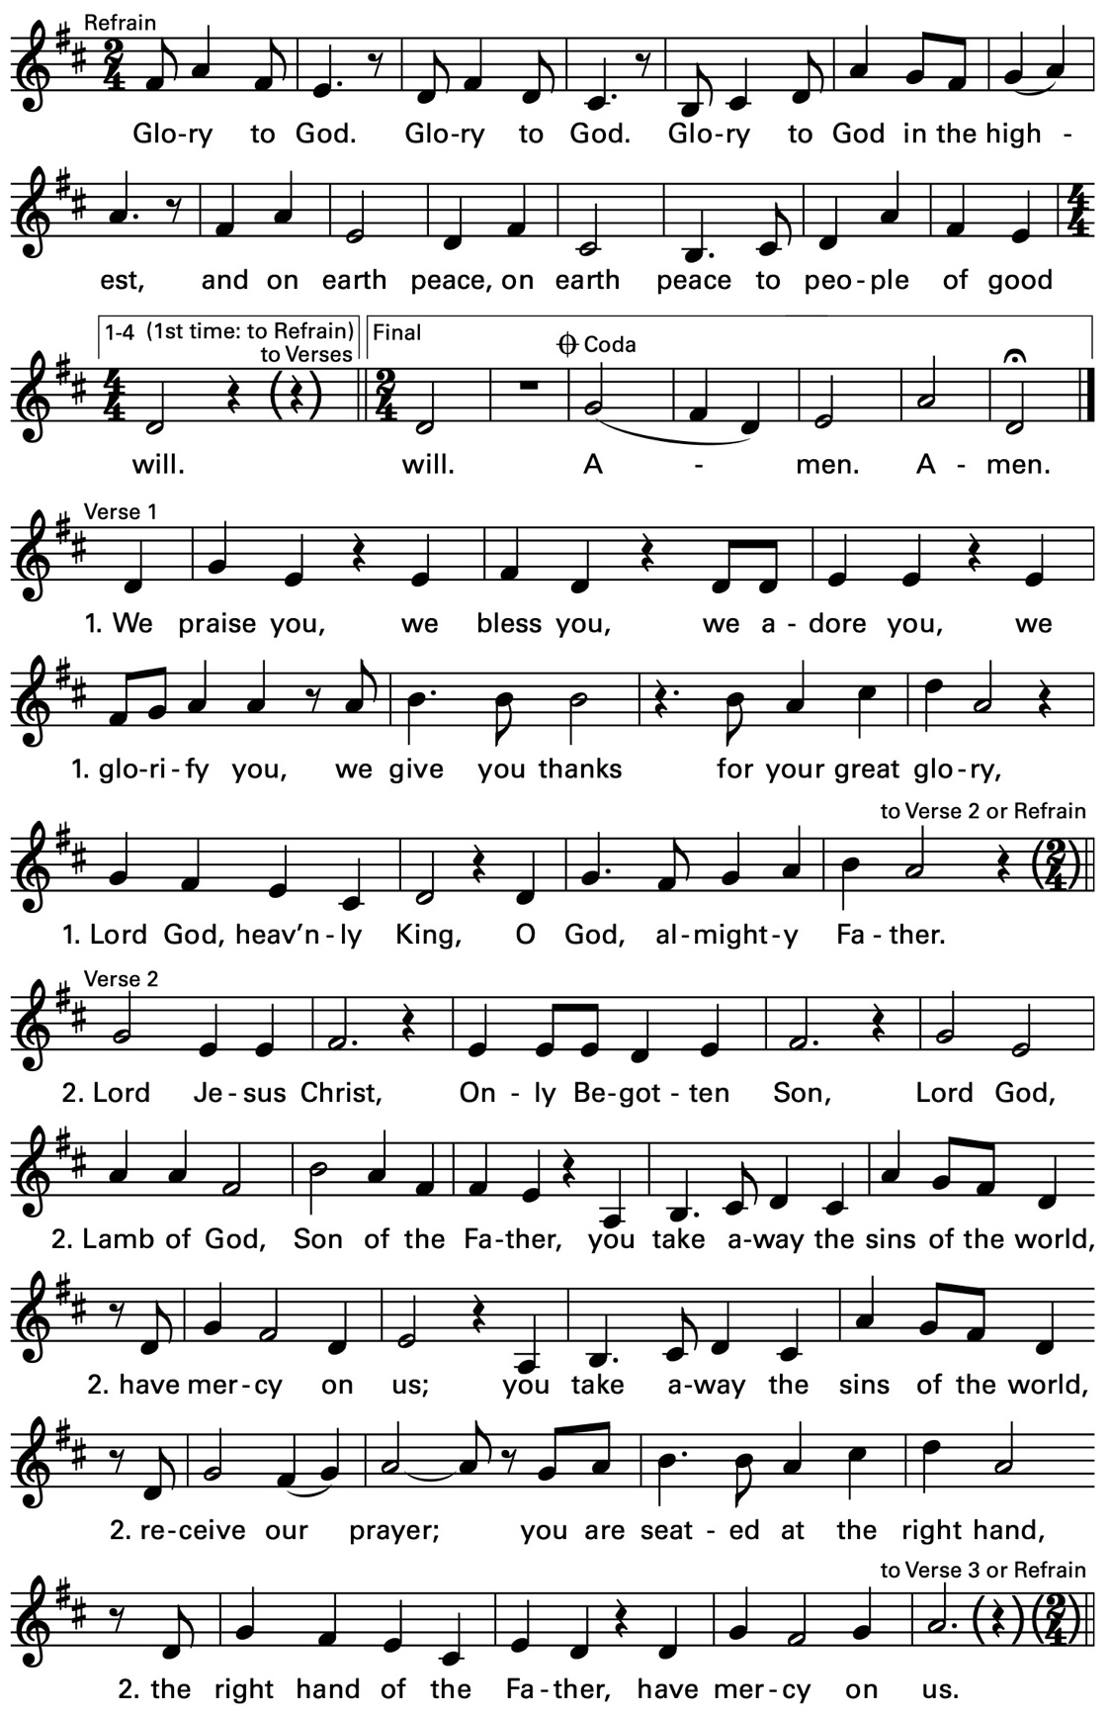

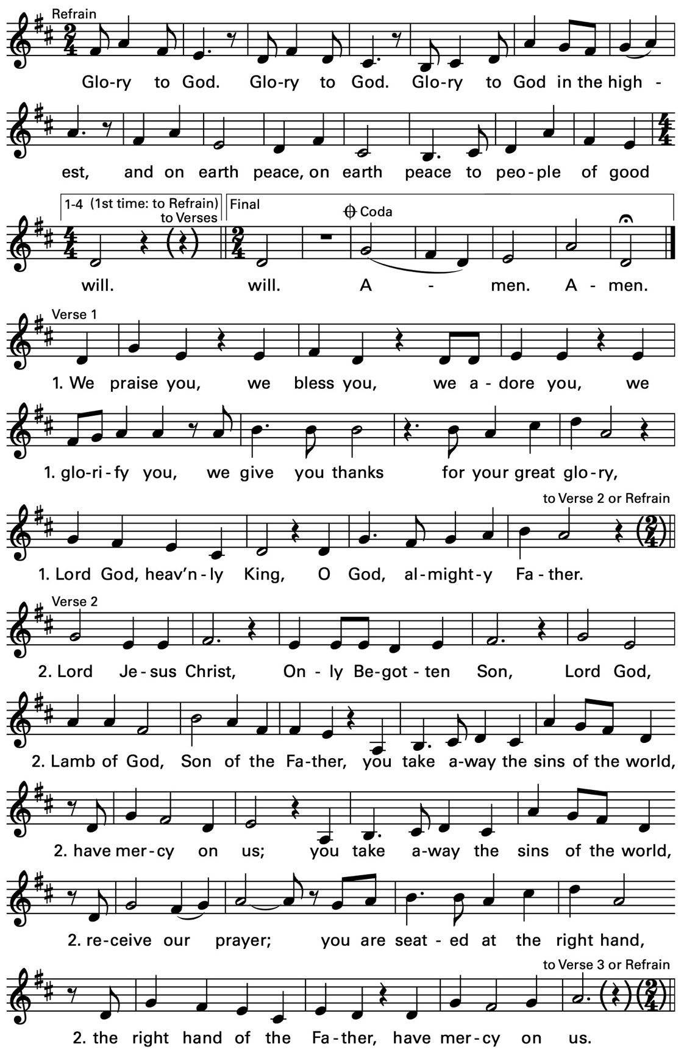

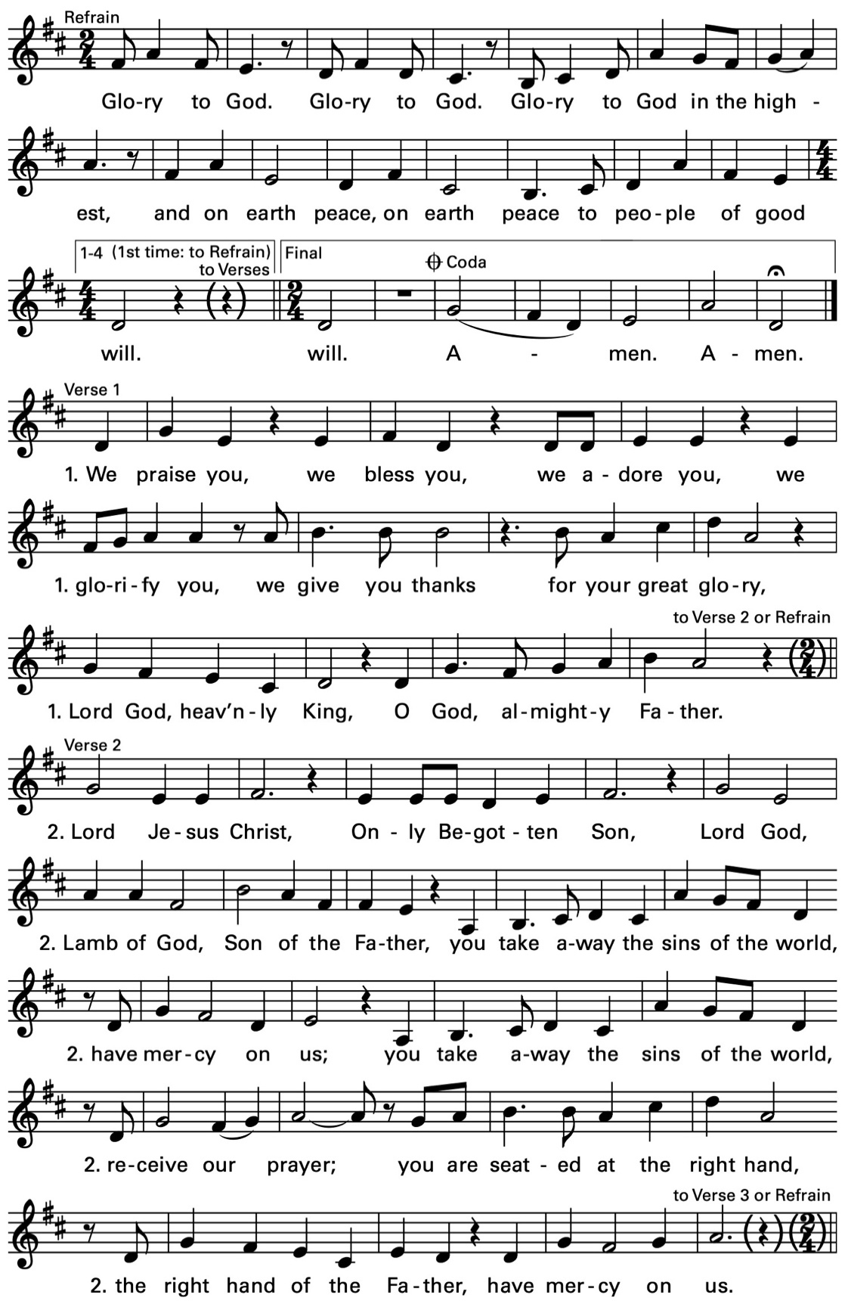

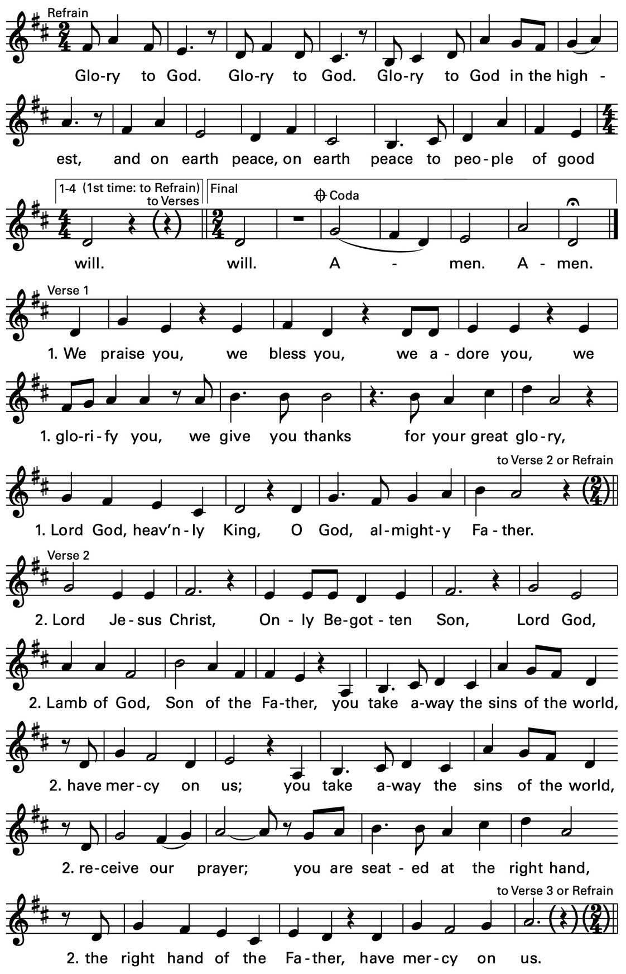

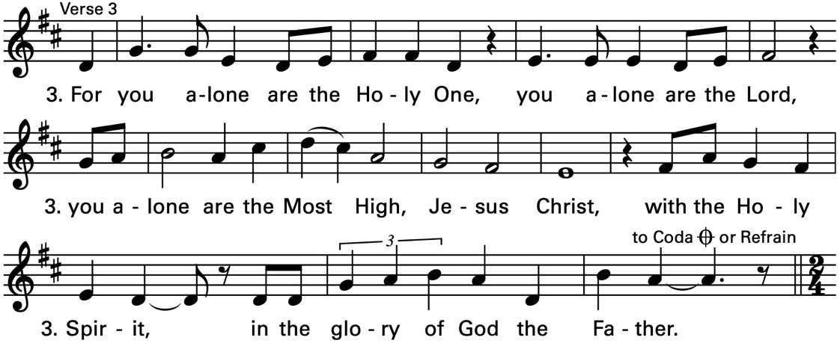

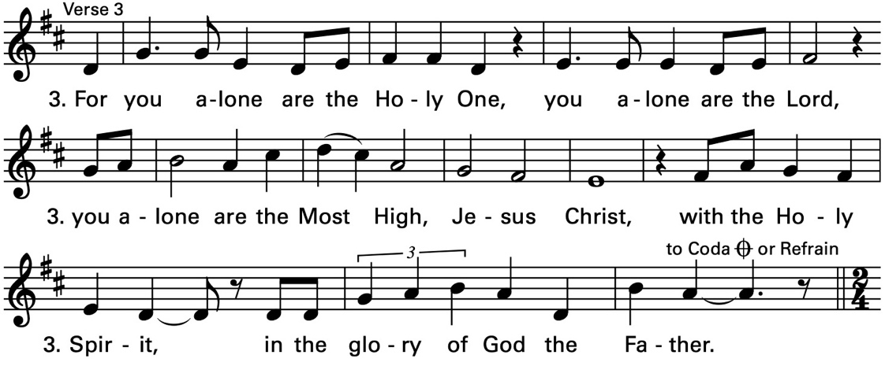

Text © 2010, ICEL. All rights reserved. Used with permission. Music © 2007, 2009, Daniel L. Schutte. Published by OCP. All rights reserved.

The Collect of the Day

The Celebrant says to the people
The Lord be with you.
People And also with you.
Celebrant Let us pray.
Father in heaven, who at the baptism of Jesus in the River Jordan proclaimed him your beloved Son and anointed him with the Holy Spirit: Grant that all who are baptized into his Name may keep the covenant they have made, and boldly confess him as Lord and Savior; who with you and the Holy Spirit lives and reigns, one God, in glory everlasting. Amen.
The Lessons

The people sit. One or two lessons, as appointed, are read, the Reader first saying
A Reading from the prophet Isaiah (43:1-7)
Thus says the Lord, he who created you, O Jacob, he who formed you, O Israel: Do not fear, for I have redeemed you; I have called you by name, you are mine. When you pass through the waters, I will be with you; and through the rivers, they shall not overwhelm you; when you walk through fire you shall not be burned, and the flame shall not consume you. For I am the Lord your God, the Holy One of Israel, your Savior. I give Egypt as your ransom, Ethiopia and Seba in exchange for you. Because you are precious in my sight, and honored, and I love you, I give people in return for you, nations in exchange for your life. Do not fear, for I am with you; I will bring your offspring from the east, and from the west I will gather you; I will say to the north, "Give them up," and to the south, "Do not withhold; bring my sons from far away and my daughters from

the end of the earth—everyone who is called by my name, whom I created for my glory, whom I formed and made."

The Word of the Lord.
People Thanks be to God.

Silence may follow

Psalm 29

1 Ascribe to the Lord, you gods, *
ascribe to the Lord glory and strength.

2 Ascribe to the Lord the glory due his Name; *
worship the Lord in the beauty of holiness.

3 The voice of the Lord is upon the waters; the God of glory thunders; *
the Lord is upon the mighty waters.

4 The voice of the Lord is a powerful voice; *
the voice of the Lord is a voice of splendor.

5 The voice of the Lord breaks the cedar trees; *
the Lord breaks the cedars of Lebanon;

6 He makes Lebanon skip like a calf, *
and Mount Hermon like a young wild ox.

7 The voice of the Lord splits the flames of fire;
the voice of the Lord shakes the wilderness; *
the Lord shakes the wilderness of Kadesh.

8 The voice of the Lord makes the oak trees writhe *
and strips the forests bare.

9 And in the temple of the Lord *
all are crying, "Glory!"

10 The Lord sits enthroned above the flood; *
the Lord sits enthroned as King for evermore.

11 The Lord shall give strength to his people; *
the Lord shall give his people the blessing of peace.

Silence may follow.
A Reading from the Acts of the Apostles (8:14-17)
When the apostles at Jerusalem heard that Samaria had accepted the word of God, they sent Peter and John to them. The two went down and prayed for them that they might receive the Holy Spirit (for as yet the Spirit had not come upon any of them; they had only been baptized in the name of the Lord Jesus). Then Peter and John laid their hands on them, and they received the Holy Spirit.
The Word of the Lord.
People Thanks be to God.
Hymnal 121 – Christ, when for us you were baptized
Deacon The Holy Gospel of our Lord Jesus Christ
according to Luke (3:15-17, 21-22)
People Glory to you, Lord Christ.
As the people were filled with expectation, and all were questioning in their hearts concerning John, whether he might be the Messiah, John answered all of them by saying, "I baptize you with water; but one who is more powerful than I is coming; I am not worthy to untie the thong of his sandals. He will baptize you with the Holy Spirit and fire. His winnowing fork is in his hand, to clear his threshing floor and to gather the wheat into his granary; but the chaff he will burn with unquenchable fire." Now when all the people were baptized, and when Jesus also had been baptized and was praying, the heaven was opened, and the Holy Spirit descended upon him in bodily form like a dove. And a voice came from heaven, "You are my Son, the Beloved; with you I am well pleased."
After the Gospel, the Reader says
The Gospel of the Lord.
People Praise to you, Lord Christ.
The Sermon The Rev. Mike Mayor

All standing
Presentation and Examination of the Candidate
The Celebrant says
The Candidate for Holy Baptism will now be presented.
Sponsor I present N. to receive the Sacrament of Baptism.
The Celebrant asks the candidate when presented
Do you desire to be baptized?
Candidate I do.
When all have been presented the Celebrant asks the parents and godparents
Will you be responsible for seeing that the child you present
is brought up in the Christian faith and life?
Parents and Godparents I will, with God's help.
Celebrant
Will you by your prayers and witness help this child to grow
into the full stature of Christ?
Parents and Godparents I will, with God's help.
Then the Celebrant asks the following questions of the candidates who can speak for themselves, and of the parents and godparents who speak on behalf of the infants and younger children
Question Do you renounce Satan and all the spiritual forces
of wickedness that rebel against God?
Answer I renounce them.
Question Do you renounce the evil powers of this world
which corrupt and destroy the creatures of God?
Answer I renounce them.
Question Do you renounce all sinful desires that draw you
from the love of God?
Answer I renounce them.
Question Do you turn to Jesus Christ and accept him as your
Savior?
Answer I do.
Question Do you put your whole trust in his grace and love?
Answer I do.
Question Do you promise to follow and obey him as your
Lord?
Answer I do.
After all have been presented, the Celebrant addresses the congregation, saying
Will you who witness these vows do all in your
power to support this person in his life in Christ?
People We will.
The Celebrant then says these or similar words
Let us join with him who is committing himself to Christ and renew our own baptismal covenant.
The Baptismal Covenant
Celebrant Do you believe in God the Father?
People I believe in God, the Father almighty,
creator of heaven and earth.
Celebrant Do you believe in Jesus Christ, the Son of God?
People I believe in Jesus Christ, his only Son, our Lord.
He was conceived by the power of the Holy Spirit
and born of the Virgin Mary.
He suffered under Pontius Pilate,
was crucified, died, and was buried.
He descended to the dead.
On the third day he rose again.
He ascended into heaven,
and is seated at the right hand of the Father.
He will come again to judge the living and the dead.
Celebrant Do you believe in God the Holy Spirit?
People I believe in the Holy Spirit,
the holy catholic Church,
the communion of saints,
the forgiveness of sins,
the resurrection of the body,
and the life everlasting.
Celebrant Will you continue in the apostles' teaching and
fellowship, in the breaking of the bread, and in the
prayers?
People I will, with God's help.
Celebrant Will you persevere in resisting evil, and, whenever
you fall into sin, repent and return to the Lord?
People I will, with God's help.
Celebrant Will you proclaim by word and example the Good
News of God in Christ?
People I will, with God's help.
Celebrant Will you seek and serve Christ in all persons, loving
your neighbor as yourself?
People I will, with God's help.
Celebrant Will you strive for justice and peace among all
people, and respect the dignity of every human
being?
People I will, with God's help.

Prayers for the Candidate
The Celebrant then says to the congregation
Let us now pray for this person who is to receive the
Sacrament of new birth.
A Person appointed leads the following petitions
Leader Deliver him, O Lord, from the way of sin and death.
People Lord, hear our prayer.
Leader Open his heart to your grace and truth.
People Lord, hear our prayer.
Leader Fill him with your holy and life-giving Spirit.
People Lord, hear our prayer.
Leader Keep him in the faith and communion of your holy Church.
People Lord, hear our prayer.
Leader Teach him to love others in the power of the Spirit.
People Lord, hear our prayer.
Leader Send him into the world in witness to your love.
People Lord, hear our prayer.
Leader Bring him to the fullness of your peace and glory.
People Lord, hear our prayer.
The Celebrant says
Grant, O Lord, that all who are baptized into the death of Jesus Christ your Son may live in the power of his resurrection and look for him to come again in glory; who lives and reigns now and forever. Amen.

Thanksgiving over the Water
The Celebrant blesses the water, first saying
The Lord be with you.
People And also with you.
Celebrant Let us give thanks to the Lord our God.
People It is right to give him thanks and praise.
Celebrant
We thank you, Almighty God, for the gift of water. Over it the Holy Spirit moved in the beginning of creation. Through it you led the children of Israel out of their bondage in Egypt into the land of promise. In it your Son Jesus received the baptism of John and was anointed by the Holy Spirit as the Messiah, the Christ, to lead us, through his death and resurrection, from the bondage of sin into everlasting life.
We thank you, Father, for the water of Baptism. In it we are buried with Christ in his death. By it we share in his resurrection. Through it we are reborn by the Holy Spirit. Therefore in joyful obedience to your Son, we bring into his fellowship those who come to him in faith, baptizing them in the Name of the Father, and of the Son, and of the Holy Spirit.
At the following words, the Celebrant touches the water
Now sanctify this water, we pray you, by the power of your Holy Spirit, that those who here are cleansed from sin and born again may continue for ever in the risen life of Jesus Christ our Savior.
To him, to you, and to the Holy Spirit, be all honor and glory, now and for ever. Amen.

The Baptism
Each candidate is presented by name to the Celebrant, or to an assisting priest or deacon, who then immerses, or pours water upon, the candidate, saying
N., I baptize you in the Name of the Father, and of the Son, and of the Holy Spirit. Amen.
When this action has been completed for all candidates, the Bishop or Priest, at a place in full sight of the congregation, prays over them, saying
Let us pray.
Heavenly Father, we thank you that by water and the Holy Spirit you have bestowed upon this your servant the forgiveness of sin, and have raised him to the new life of grace. Sustain him, O Lord, in your Holy Spirit. Give him an inquiring and discerning heart, the courage to will and to persevere, a spirit to know and to love you, and the gift of joy and wonder in all your works. Amen.
Then the Bishop or Priest places a hand on the person's head, marking on the forehead the sign of the cross [using Chrism if desired] and saying to each one
N., you are sealed by the Holy Spirit in Baptism and marked as Christ's own for ever. Amen.
Or this action may be done immediately after the administration of the water and before the preceding prayer.
When all have been baptized, the Celebrant says
Let us welcome the newly baptized.
Celebrant and People
We receive you into the household of God. Confess the faith of Christ crucified, proclaim his resurrection, and share with us in his eternal priesthood.

The Celebrant then asperges the people.

The Peace

All stand. The Celebrant says to the people
The peace of the Lord be always with you.
People And also with you.

Then the Ministers and People may greet one another in the name of the Lord.
Offertory Solo – Peter Herpst

Doxology

The Great Thanksgiving – Eucharistic Prayer B
The people remain standing.
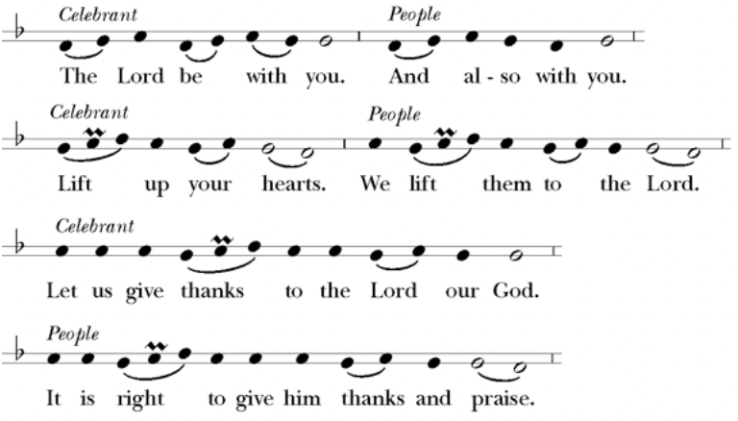
Then, facing the Holy Table, the Celebrant proceeds
It is right, and a good and joyful thing, always and every- where to give thanks to you, Father Almighty, Creator of heaven and earth.
Here a Proper Preface is sung or said on all Sundays, and on other occasions as appointed.
Therefore we praise you, joining our voices with Angels and Archangels and with all the company of heaven, who for ever sing this hymn to proclaim the glory of your Name:
Celebrant and People
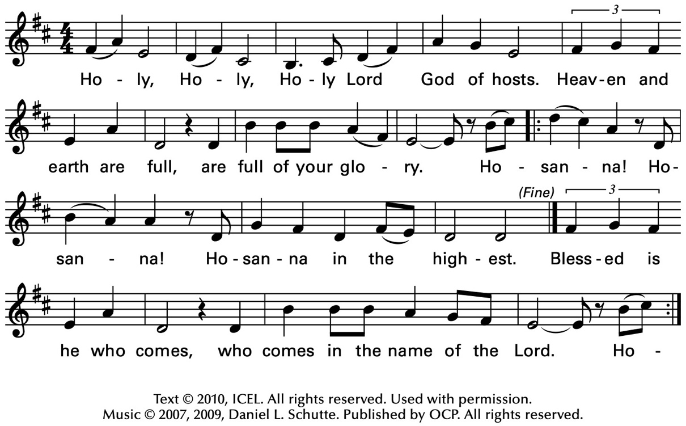
The people stand or kneel.
The Celebrant continues
We give thanks to you, O God, for the goodness and love which you have made known to us in creation; in the calling of Israel to be your people; in your Word spoken through the prophets; and above all in the Word made flesh, Jesus, your Son. For in these last days you sent him to be incarnate from the Virgin Mary, to be the Savior and Redeemer of the world. In him, you have delivered us from evil, and made us worthy to stand before you. In him, you have brought us out of error into truth, out of sin into righteousness, out of death into life.
On the night before he died for us, our Lord Jesus Christ took bread; and when he had given thanks to you, he broke it, and gave it to his disciples, and said, “Take, eat: This is my Body, which is given for you. Do this for the remembrance of me.”
After supper he took the cup of wine; and when he had given thanks, he gave it to them, and said, “Drink this, all of you: This is my Blood of the new Covenant, which is shed for you and for many for the forgiveness of sins. Whenever you drink it, do this for the remembrance of me.”

Therefore, according to his command, O Father,
Celebrant and People
We remember his death,
We proclaim his resurrection,
We await his coming in glory;
The Celebrant continues
And we offer our sacrifice of praise and thanksgiving to you, O Lord of all; presenting to you, from your creation, this bread and this wine.
We pray you, gracious God, to send your Holy Spirit upon these gifts that they may be the Sacrament of the Body of Christ and his Blood of the new Covenant. Unite us to your Son in his sacrifice, that we may be acceptable through him, being sanctified by the Holy Spirit. In the fullness of time, put all things in subjection under your Christ, and bring us to that heavenly country where, with all your saints, we may enter the everlasting heritage of your sons and daughters; through Jesus Christ our Lord, the firstborn of all creation, the head of the Church, and the author of our salvation.
By him, and with him, and in him, in the unity of the Holy Spirit all honor and glory is yours, Almighty Father, now and for ever.

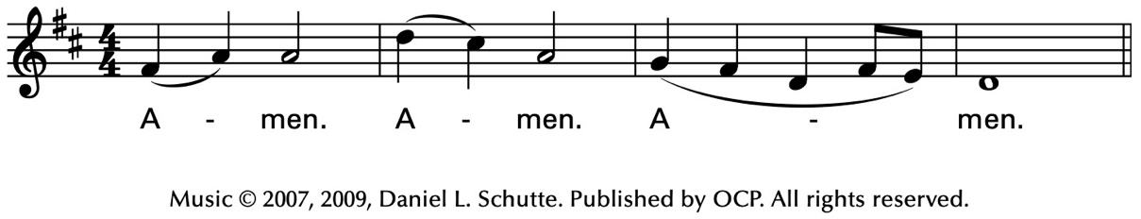

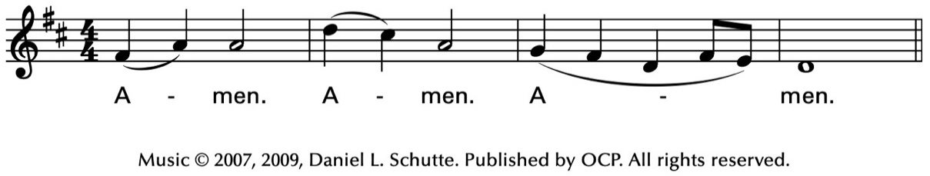

Celebrant
As our Savior Christ
has taught us,
we now pray,
People and Celebrant
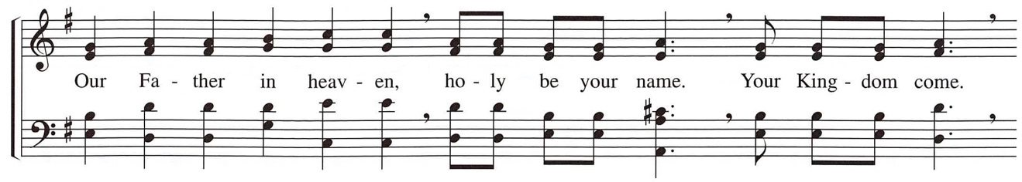
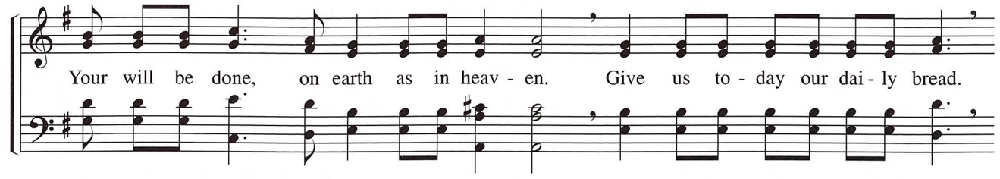
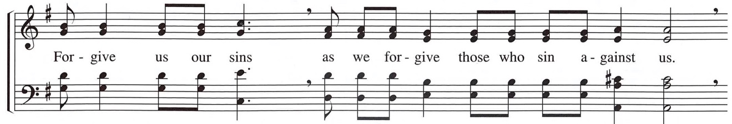
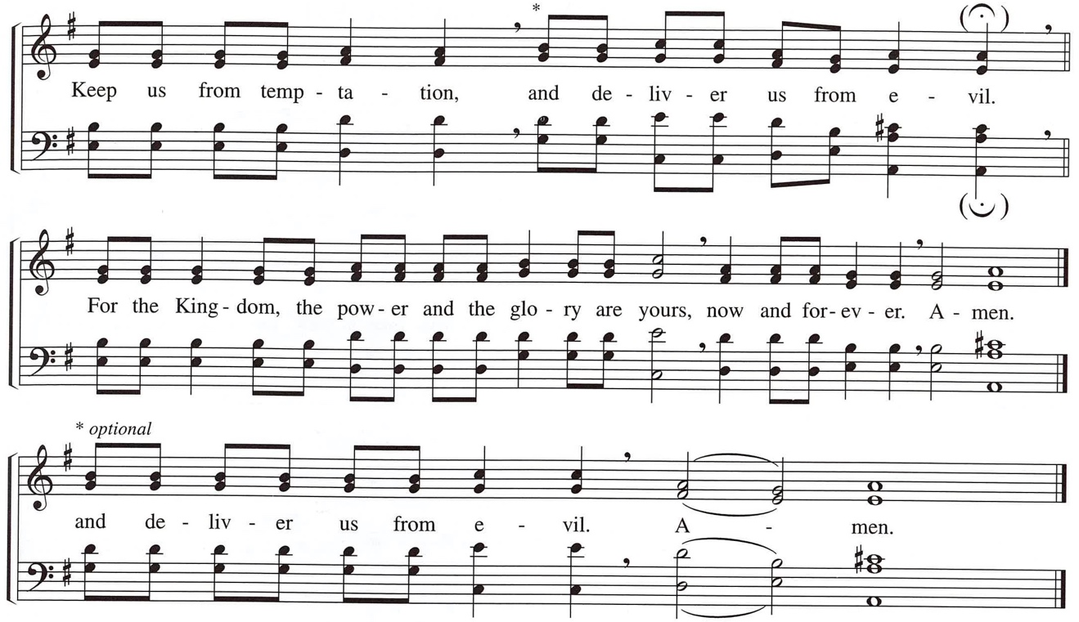
Copyright © 1998 Ateliers et Presses de Taizé (France)
The Breaking Of The Bread
The Celebrant breaks the consecrated Bread. A period of silence is kept.
Then may be sung or said
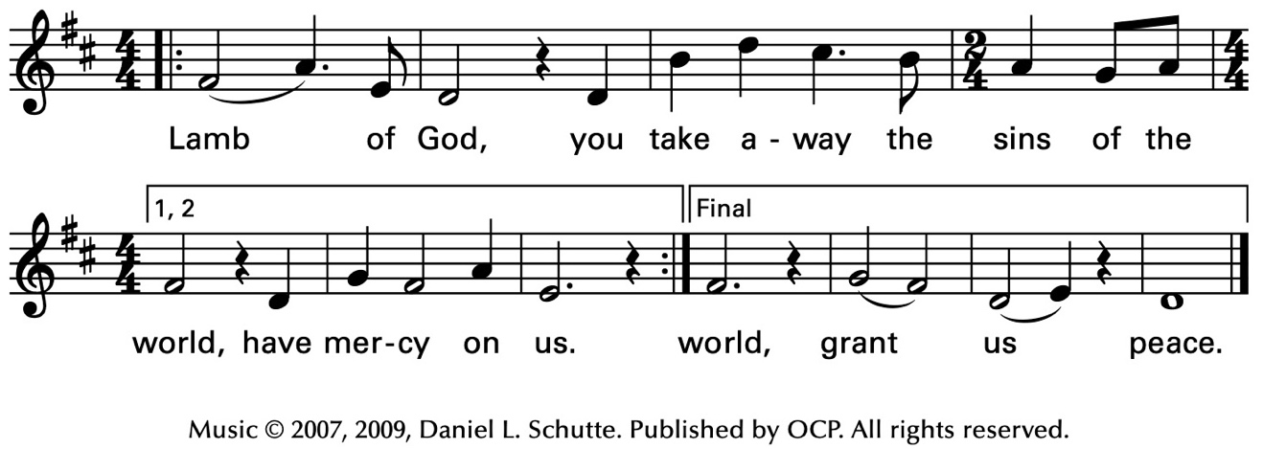
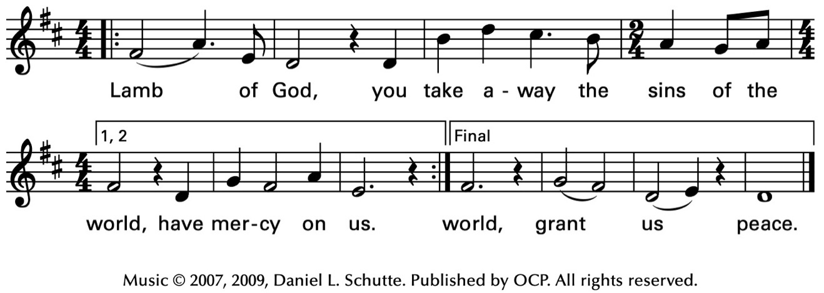
Facing the people, the Celebrant says the following Invitation
The Gifts of God for the People of God.
and may add Take them in remembrance that Christ died for
you, and feed on him in your hearts by faith,
with thanksgiving.
The ministers immediately deliver the Sacrament to the people.
The Sacrament is given to the communicants with these words
The Body of Christ, the bread of heaven. [Amen.]
The Blood of Christ, the cup of salvation. [Amen.]
Hymn 448 – O love, how deep
After communion the Celebrant says
Let us pray.
Celebrant and People
Eternal God, heavenly Father,
you have graciously accepted us as living members
of your Son our Savior Jesus Christ,
and you have fed us with spiritual food
in the Sacrament of his Body and Blood.
Send us now into the world in peace,
and grant us strength and courage
to love and serve you
with gladness and singleness of heart;
through Christ our Lord. Amen.
The Celebrant may bless the people.

Hymnal 637 – How firm a foundation
Deacon Let us go forth in the name of Christ.
People Thanks be to God.
Postlude

Announcements
﻿Annual Meeting
Mark your calendars now for the annual parish meeting on Sunday, January 26 following the 10 am service. At the meeting there will be a report on the state of the parish from the Rector and Wardens as well as elections for Vestry and delegates for the Diocesan Convention.
Ministry Fair
On Sunday, January 26 following the annual meeting there will be a ministry fair in the parish hall during fellowship time. This is a fun and interesting way to learn about all the ministry opportunities there are at Christ Church, to celebrate the work of our members, and to consider how you might be involved in the work of the Church.
Altar Guild Flower Chart
The 2025 Altar Guild Flower Chart is now available in the Parish Hall. The cost is $25 and there are envelopes at the bottom of the chart. The Flower Chart allows at least 2 people to sign up for flowers on the same date. The goal is to be able to offer everyone the opportunity to choose an important date that has a special meaning to them.
Fellowship Book Group
Please join us for fellowship and lively discussion. We start with fellowship at 6:00 pm and discussion starts at 6:30 pm. We’d love to have you join us.
The next meeting will be on our usual meeting day, (4th Monday of the month) January 27, 2025 via zoom.
The Zoom link and passcode are:
Meeting ID: TBD
Passcode: TBD

The book for January will be The Rev. Clare Fergusson & Russ Van Alstyne Mysteries #2: A Fountain Filled with Blood by Julia Spencer-Fleming. (Found at various discount stores, Kindle, Audible, paperback)
﻿"Nestled in the heart of the Adirondacks, Miller's Kill, New York is about as safe as it gets. That's why Episcopal minister Clare Fergusson is shocked when the July Fourth weekend brings a rash of vicious assaults to the scenic town. Even Clare's good friend, police chief Russ Van Alstyne, is shaken by the brutality of the crimes-especially when it appears that the victims were chosen because they are gay. But when a third assault of an out-of-town developer ends in murder, Clare and Russ wonder if the recent crime wave is connected to the victim's controversial plan to open an upscale spa in Miller's Kill. But not all things in the tiny town are what they seem-and soon, Clare and Russ are left to fight their unspoken attraction to one another even as they uncover a labyrinthine conspiracy that threatens to turn deadly for them both..."
﻿Questions? Speak with any of the following: Shelly Fairbanks, DeeDee Fournier, Sandi Carter, Jen Killion, Melinda Jackson
Ministry Moment - Christian Education/Sunday School
Youth ministry at Christ Church reaches preschool and grade school children using a Montessori style program with beautifully constructed visuals. We share the old and new testament stories of God's people on their journey.
﻿Two staff allow sharing the program and safe oversight during 30 to 40 minutes of hearing a story, seeing an act of it they might recreate and prayer.

New Year's Day Lunch Thanks
Deacon Linda and Susan Myers
On Wednesday, January 1, 2025, Christ Church had a New Year's Day Lunch for the homeless community and for our own church members.
There was a lot of co-mingling between the two communities and that was so heartwarming to see. As people left, phone numbers were exchanged, good-byes were said and praises of "Happy New Year" were exchanged.
Thank you to everyone who provided food, washed dishes, rinsed dishes, volunteered to serve, and cleaned up. In fact, we left the parish hall in a more cleaner state than we found it. Thank you to those who vacuumed the floors; moved furniture so the floor could be vacuumed, and scrubbed the dirty spots on the floor making the floor look so clean and shiny. What a blessing you all are!
This was a very fun event and suggestions are already coming in as to what we can do next year.
Well done, one and all!
Gateway Thanks
Thank you to Christ Church comes from the Gateway Program of Puyallup High School. The Gateway program provides real world experiences to students with disabilities in the areas of making a product, advertising, shopping, budgeting, and selling. Every Wednesday Gateway students come to Christ Church and set up the tables for the Soup Kitchen. They put tablecloths on the table, put out plates, butter packets, glasses, silverware, salt & pepper shakers, and water pitchers. In the afternoon the students return and vacuum the carpet in the Sanctuary, dust the windowsills and vacuum the hallways and the carpeted area in front of the kitchen and the front door of the church. They also wipe down all the windowsills and the tables in the parish hall.
Just before Christmas Deacon Linda gave a Christmas party for the Gateway students, and the school staff. She arranged for everyone to come to Th3ee Coffee Shop run by Immanuel Lutheran church. The Gateway Director told Deacon Linda "I have told the Puyallup School District Board of Directors about Christ Church. They know about your church." She told them Christ Church is hospitable and so generous with letting the Gateway group come to Christ Church and all the Gateway students and the entire school staff are treated so extraordinarily well at Christ Church!
﻿Hospitality is not merely a social duty but a reflection of God's love and grace. It is a tangible way to demonstrate the Gospel, welcoming others as Christ has welcomed us. Well done Christ Church!
Greening The Church Thanks
Deacon Linda
Thank you to everyone who helped "green the church." Many people showed up and put out the candelabras, set up the Christmas trees, prepared the Nativity set, placed candles in the candelabras, arranged the flowers, decorated the wreaths, placed greens on the windowsills, set up the center aisle candles, and prepared the church for Christmas services.
Thank you for generously giving your time and energy to make our church so beautiful for the Christmas season. It’s such a great blessing to have such amazing members like you.
Many, many, many people, both visitors and members, commented on Christmas Eve, Christmas Day, and the Sundays after Christmas how beautiful Christ Church looks. One person told me, "this church looks exactly like a church should for Christmas." Well done, everyone!

Puyallup Food Bank Donations
Happy New Year! Yep, another year is nearly in the history books and a brand new one is on the verge of being here.
So, what can we do to help others be upbeat about tackling this new year?
A few ideas -
- Paper products of all kinds
- Hygiene products
- Warm drinks
- Any shelf stable ideas that you have and would like to donate.
As always, any monies you would like to give may be put in the offering plate or mailed to the church. Please be sure to mark it for the Food Bank.
Thank you for all your help that you give to the Food Bank!
Judy Hansen, Vestry
Soup Kitchen
Susan Myers and Deacon Linda
Thank you Kathy M. for providing soup, Steve A. for providing fruit and serving, and Maria H. for providing juices. Thank you Barb J., Lynn and Calvin S., and Susan M. for volunteering to serve where needed..
This week's totals:
- Guests served: 20
- Bus passes given out: 13
- How many picked up mail: 10
- Toiletries given out: 19
- Socks given away: 14
- Laundry Packets given out: 18
Hospitality/Toiletry Items Needed:
- Toothbrushes
- Kleenex Packets
- Hand Lotion
Thank you for your support of this ministry to feed those in need.

Sermon Notes
Today's Ministers of Worship:

Celebrant: The Rev. Mike Mayor
Deacon: The Rev. Linda Potter
Lectors: Jen Killion, Carla Golden
Acolyte: Rolin Stone
Eucharistic Minister: Jeremy Duplissey
Live Stream Coordinator: Bonnie Quintana
Pianist: Vicki Melton
Usher: Jean Hissong
Greeters: Carla Golden, Helen Godwin, Christine Scholer, DeeDee Fournier
Closer: Sue Golden
Altar Guild: Cindy Johnson, Susan Myers, Christine Scholer, Jean Irey
Music permission through OneLicense #A-706918

Scan to give online. All payments are processed through Paypal.
Christ Episcopal Church
A congregation of the Episcopal Diocese of Olympia
Bishop – The Rt. Rev. Philip N. LaBelle
Rector – The Rev. Mike Mayor
Vestry
Sr. Warden – Sue Golden
Jr. Warden for Property – vacant
Jr. Warden for Communication – Nancy Nesheim
Treasurer – Melinda Jackson
Clerk – Tanya Elder
Member – Maria Haack
Member – Judy Hansen
Member – John Hopkins
Member – Kathy Mason
Member – Susan Myers
Member – Sean Williams
210 5th St. SW | Puyallup, WA | 98371
253-848-2323 | office@episcopallup.com
www.episcopallup.com

