Seventh Sunday after
the Epiphany
Morning Prayer, Rite II

10:00 am – February 23, 2025

Welcome to Christ Church
We are so happy you have chosen to come and participate in worship this morning. Your presence today strengthens the Body of Christ, not only here but throughout the world.
Land Acknowledgment
Christ Church acknowledges that we gather on the traditional homeland of the Puyallup Tribe. The Puyallup people have lived on and stewarded these lands since the beginning of time, and continue to do so today. We honor and give thanks for the land itself and the life of all the indigenous peoples of this area.
New to Christ Church?
Welcome to Christ Episcopal Church of Puyallup. Wherever you are on your spiritual journey, you are welcome here! We invite you to sign our guestbook, visit our website (www.episcopallup.com) or connect with one of the clergy.
Questions?
Please ask. The usher (the person who gave you a bulletin) can answer your questions or concerns. Restrooms are available in the hallway to the west of the worship space.
About our Liturgy
Worship lies at the heart of the Christian life. It is in worship that we express our theology and define our identity. We encounter God within worship and are formed and transformed as the people of God. One of the hallmarks of the Episcopal Church is its liturgical worship. Liturgy literally is “the work of the people,” and refers to the patterns, forms, words, and actions through which public worship is conducted.
Hymnal 5 – O splendor of God’s glory bright

The Officiant begins the service with one or more of these sentences of Scripture
From the rising of the sun to its setting my Name shall be great among the nations, and in every place incense shall be offered to my Name, and a pure offering: for my Name shall be great among the nations, says the Lord of hosts. Malachi 1:11

The Invitatory and Psalter
All stand
Officiant Lord, open our lips.
People And our mouth shall proclaim your praise.
Officiant and People
Glory to the Father, and to the Son, and to the Holy Spirit: as
it was in the beginning, is now, and will be for ever. Amen.
Except in Lent, add Alleluia.
Then follows
Venite Psalm 95:1-7
Come, let us sing to the Lord; *
let us shout for joy to the Rock of our salvation.
Let us come before his presence with thanksgiving *
and raise a loud shout to him with psalms.
For the Lord is a great God, *
and a great King above all gods.
In his hand are the caverns of the earth, *
and the heights of the hills are his also.
The sea is his, for he made it, *
and his hands have molded the dry land.
Come, let us bow down, and bend the knee, *
and kneel before the Lord our Maker.
For he is our God,
and we are the people of his pasture and the sheep of his hand. *
Oh, that today you would hearken to his voice!
The Psalm or Psalms Appointed
Psalm 37:1-12, 41-42

1 Do not fret yourself because of evildoers; *
do not be jealous of those who do wrong.

2 For they shall soon wither like the grass, *
and like the green grass fade away.

3 Put your trust in the Lord and do good; *
dwell in the land and feed on its riches.

4 Take delight in the Lord, *
and he shall give you your heart's desire.

5 Commit your way to the Lord and put your trust in him, *
and he will bring it to pass.

6 He will make your righteousness as clear as the light *
and your just dealing as the noonday.

7 Be still before the Lord *
and wait patiently for him.

8 Do not fret yourself over the one who prospers, *
the one who succeeds in evil schemes.

9 Refrain from anger, leave rage alone; *
do not fret yourself; it leads only to evil.

10 For evildoers shall be cut off, *
but those who wait upon the Lord shall possess the land.

11 In a little while the wicked shall be no more; *
you shall search out their place, but they will not be there.

12 But the lowly shall possess the land; *
they will delight in abundance of peace.

41 But the deliverance of the righteous comes from the Lord; *
he is their stronghold in time of trouble.

42 The Lord will help them and rescue them; *
he will rescue them from the wicked and deliver them,
because they seek refuge in him.
Glory to the Father, and to the Son, and to the Holy Spirit: *
as it was in the beginning, is now, and will be for ever. Amen.

Silence may follow.
The Lessons
One or two lessons, as appointed, are read, the Reader first saying
A Reading from the book of Genesis (45:3-11, 15)
Joseph said to his brothers, "I am Joseph. Is my father still alive?" But his brothers could not answer him, so dismayed were they at his presence. Then Joseph said to his brothers, "Come closer to me." And they came closer. He said, "I am your brother, Joseph, whom you sold into Egypt. And now do not be distressed, or angry with yourselves, because you sold me here; for God sent me before you to preserve life. For the famine has been in the land these two years; and there are five more years in which there will be neither plowing nor harvest. God sent me before you to preserve for you a remnant on earth, and to keep alive for you many survivors. So it was not you who sent me here, but God; he has made me a father to Pharaoh, and lord of all his house and ruler over all the land of Egypt. Hurry and go up to my father and say to him, 'Thus says your son Joseph, God has made me lord of all Egypt; come down to me, do not delay. You shall settle in the land of Goshen, and you shall be near me, you and your children and your children's children, as well as your flocks, your herds, and all that you have. I will provide for you there--since there are five more years of famine to come--so that you and your household, and all that you have, will not come

to poverty.'" And he kissed all his brothers and wept upon them; and after that his brothers talked with him.
The Word of the Lord.
People Thanks be to God.
Silence may be kept.
The Song of Zechariah Benedictus Dominus Deus (Hymn 444) Luke 1: 68-79
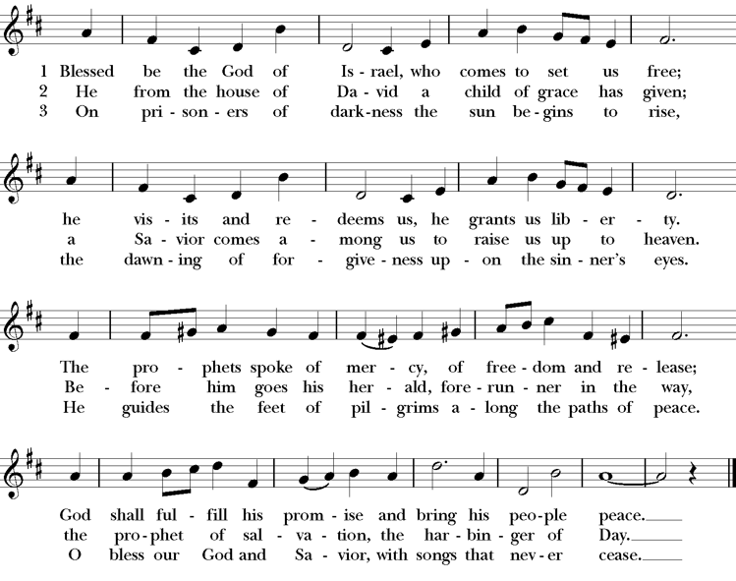
Meter: 76. 76. D. Words: Michael A. Perry (b. 1942), alt.; para. of The Song of Zechariah. Music: Thornbury, Basil Harwood (1859-1949)
Reader A Reading from Paul’s first letter to the Corinthians (15:35-38,42-50)
Someone will ask, "How are the dead raised? With what kind of body do they come?" Fool! What you sow does not come to life unless it dies. And as for what you sow, you do not sow the body that is to be, but a bare seed, perhaps of wheat or of some other grain. But God gives it a body as he has chosen, and to each kind of seed its own body. So it is with the resurrection of the dead. What is sown is perishable, what is raised is imperishable. It is sown in dishonor, it is raised in glory. It is sown in weakness, it is raised in power. It is sown a physical body, it is raised a spiritual body. If there is a physical body, there is also a spiritual body. Thus it is written, "The first man, Adam, became a living being"; the last Adam became a life-giving spirit. But it is not the spiritual that is first, but the physical, and then the spiritual. The first man was from the earth, a man of dust; the second man is from heaven. As was the man of dust, so are those who are of the dust; and as is the man of heaven, so are those who are of heaven. Just as we have borne the image of the man of dust, we will also bear the image of the man of heaven. What I am saying, brothers and sisters, is this: flesh and blood cannot inherit the kingdom of God, nor does the perishable inherit the imperishable.
The Word of the Lord.
People Thanks be to God.
Silence may be kept.
Glory to God Gloria in Excelsis

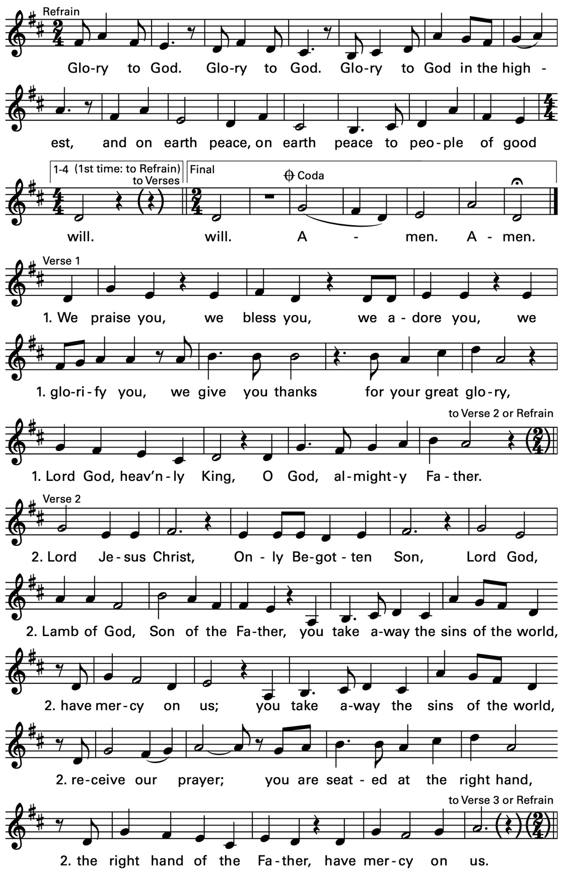

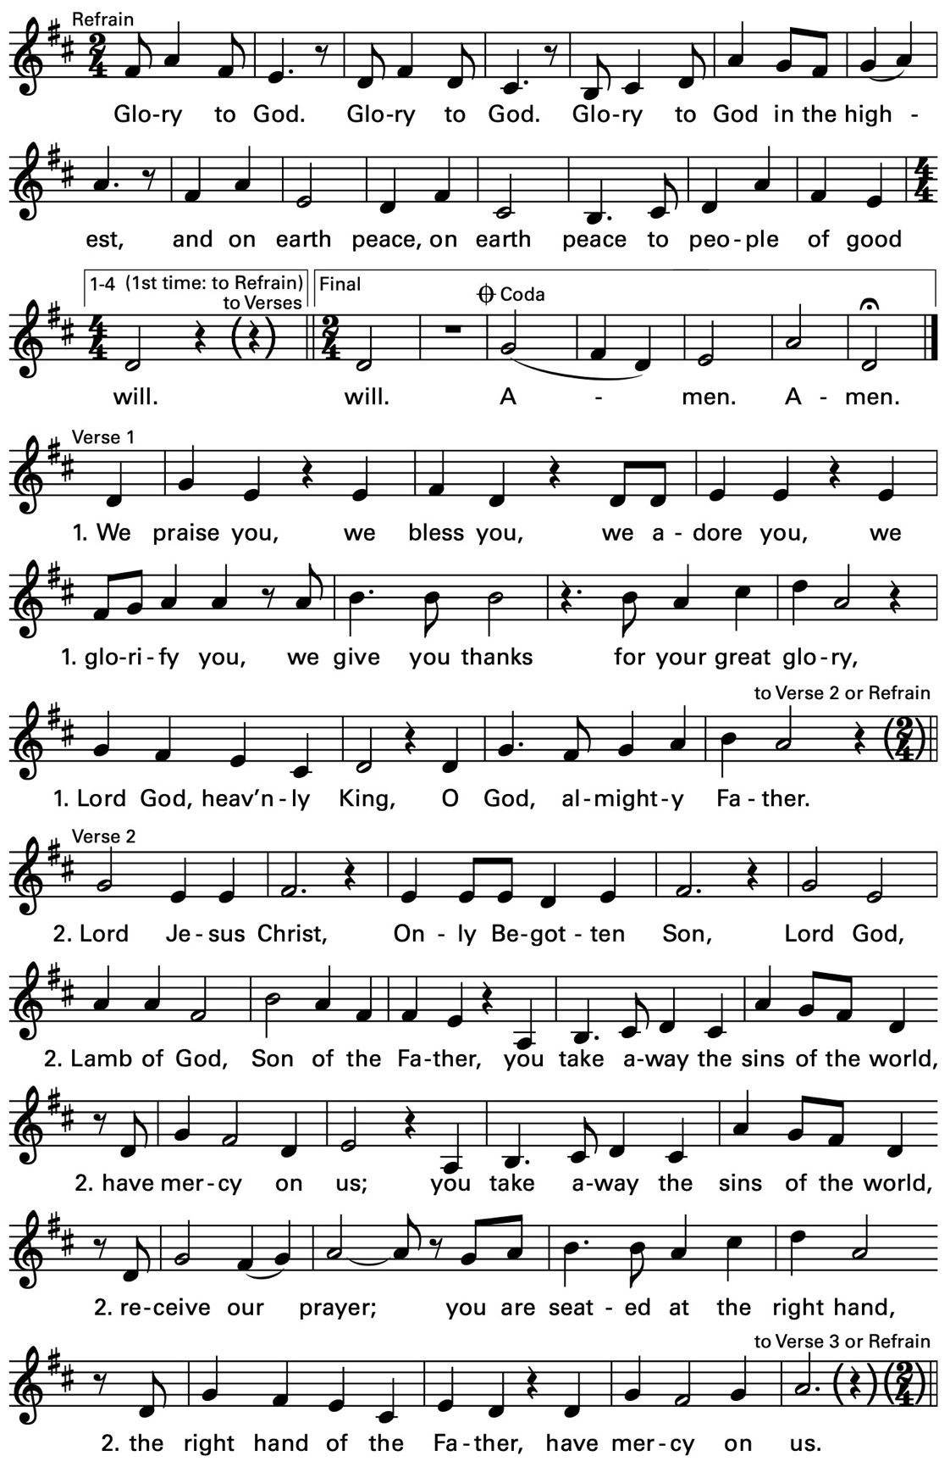

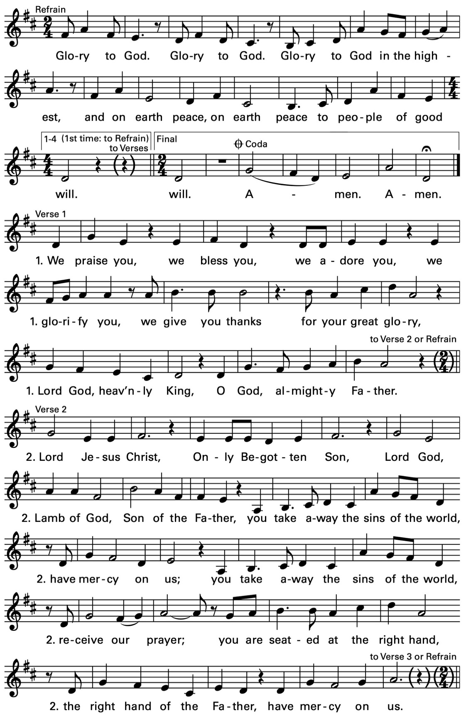

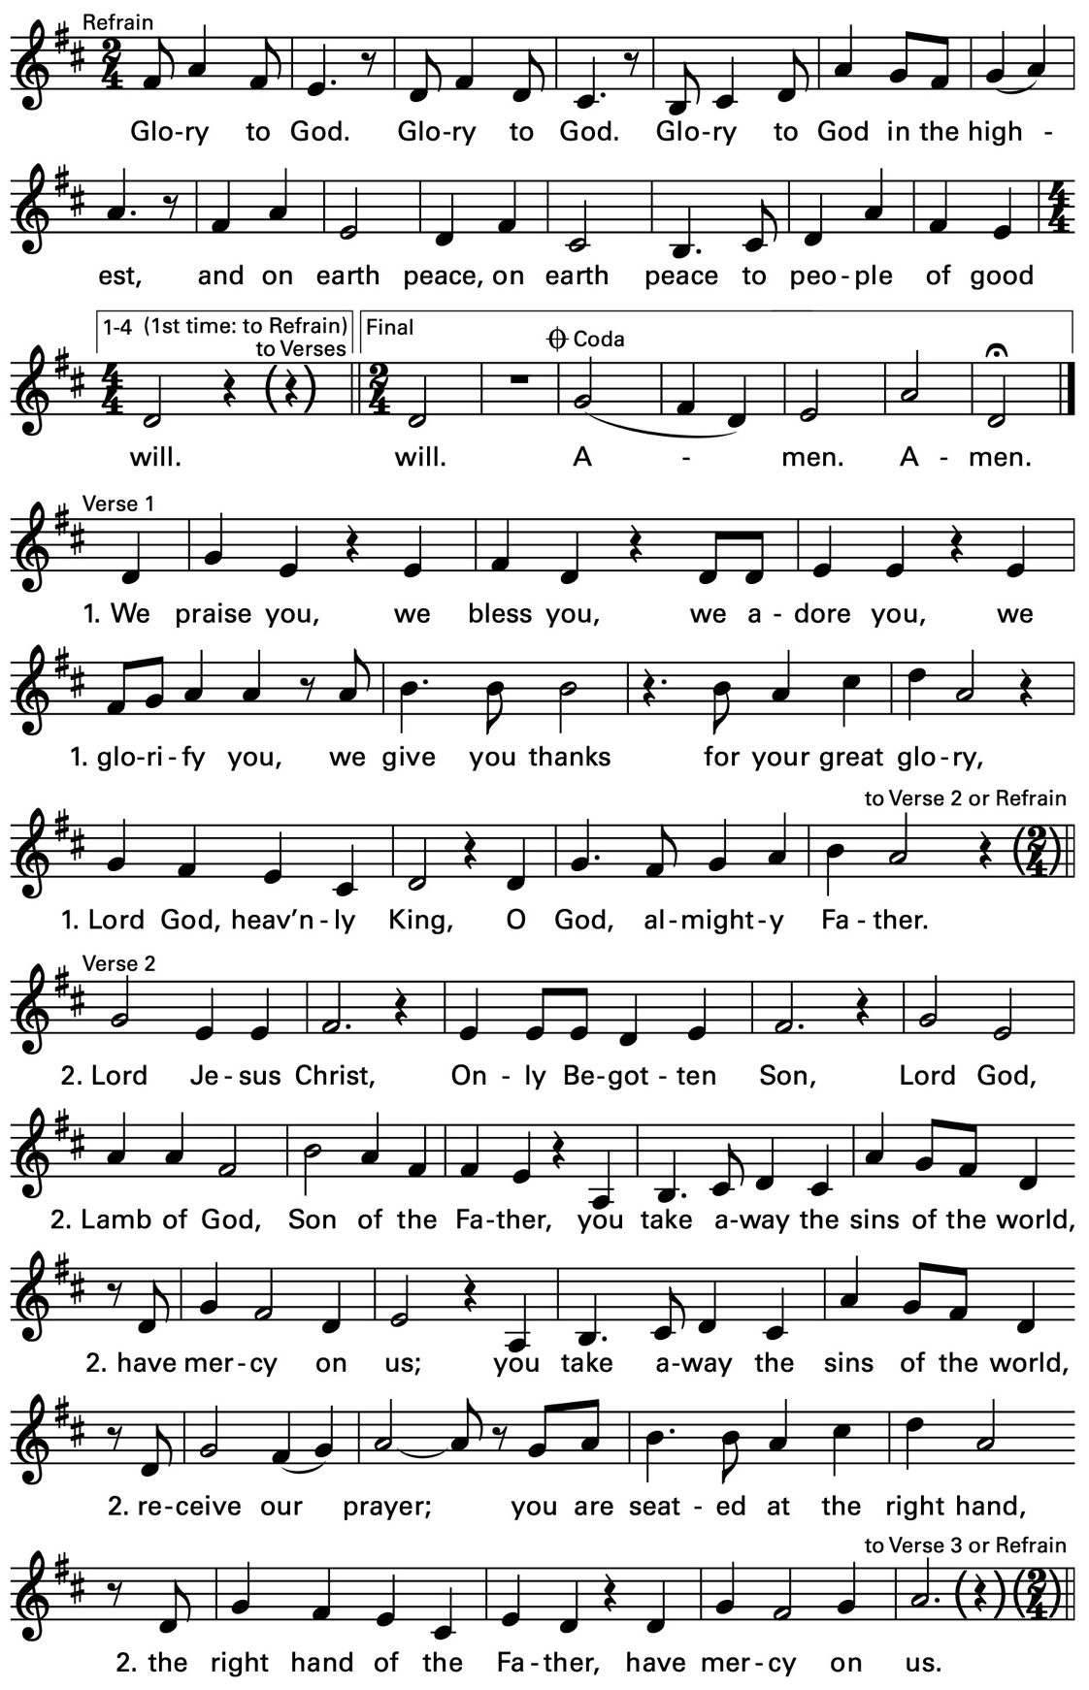

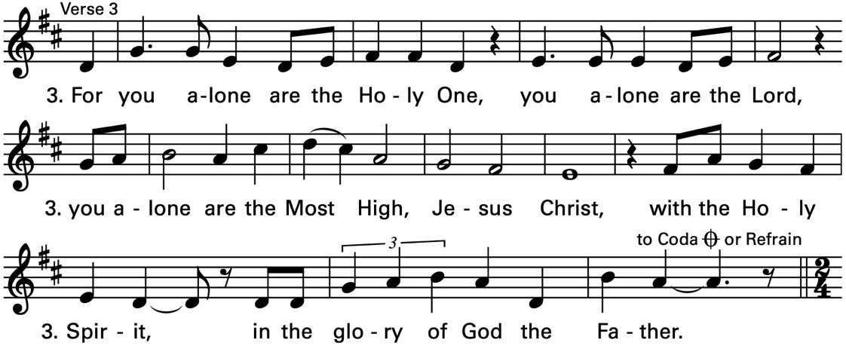

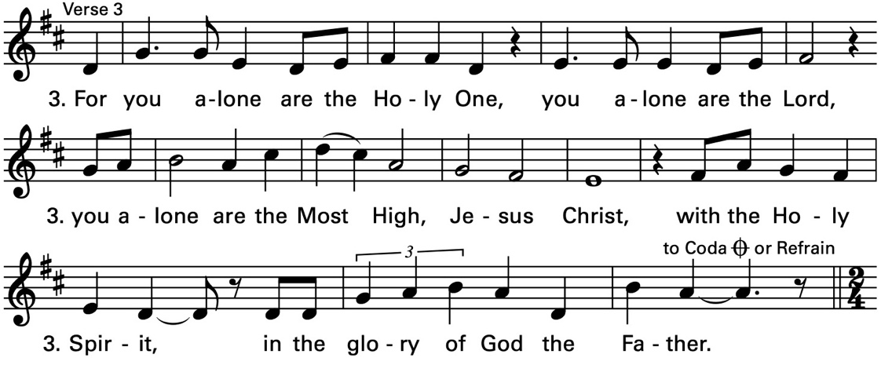
Text © 2010, ICEL. All rights reserved. Used with permission. Music © 2007, 2009, Daniel L. Schutte. Published by OCP. All rights reserved.
Reader A Reading from the Gospel according to Luke (6:27-38)
Jesus said, "I say to you that listen, Love your enemies, do good to those who hate you, bless those who curse you, pray for those who abuse you. If anyone strikes you on the cheek, offer the other also; and from anyone who takes away your coat do not withhold even your shirt. Give to everyone who begs from you; and if anyone takes away your goods, do not ask for them again. Do to others as you would have them do to you. If you love those who love you, what credit is that to you? For even sinners love those who love them. If you do good to those who do good to you, what credit is that to you? For even sinners do the same. If you lend to those from whom you hope to receive, what credit is that to you? Even sinners lend to sinners, to receive as much again. But love your enemies, do good, and lend, expecting nothing in return. Your reward will be great, and you will be children of the Most High; for he is kind to the ungrateful and the wicked. Be merciful, just as your Father is merciful. Do not judge, and you will not be judged; do not condemn, and you will not be condemned. Forgive, and you will be forgiven; give, and it will be given to you. A good measure, pressed down, shaken together, running over, will be put into your lap; for the measure you give will be the measure you get back."
The Word of the Lord.
People Thanks be to God.
Silence may be kept.
The Sermon The Rev. Linda Potter
The Apostles' Creed
Officiant and People together, all standing
I believe in God, the Father almighty,
creator of heaven and earth;
I believe in Jesus Christ, his only Son, our Lord.
He was conceived by the power of the Holy Spirit
and born of the Virgin Mary.
He suffered under Pontius Pilate,
was crucified, died, and was buried.
He descended to the dead.
On the third day he rose again.
He ascended into heaven,
and is seated at the right hand of the Father.
He will come again to judge the living and the dead.
I believe in the Holy Spirit,
the holy catholic Church,
the communion of saints,
the forgiveness of sins
the resurrection of the body,
and the life everlasting. Amen.
The Prayers
The People stand or kneel
Officiant The Lord be with you.
People And also with you.
Officiant Let us pray.

Officiant and People
Our Father, who art in heaven,
hallowed be thy Name,
thy kingdom come,
thy will be done,
on earth as it is in heaven.
Give us this day our daily bread.
And forgive us our trespasses,
as we forgive those
who trespass against us.
And lead us not into temptation,
but deliver us from evil.
For thine is the kingdom,
and the power, and the glory,
for ever and ever. Amen.
Then follows these sets of Suffrages
V. Show us your mercy, O Lord;
R. And grant us your salvation.
V. Clothe your ministers with righteousness;
R. Let your people sing with joy.
V. Give peace, O Lord, in all the world;
R. For only in you can we live in safety.
V. Lord, keep this nation under your care;
R. And guide us in the way of justice and truth.
V. Let your way be known upon earth;
R. Your saving health among all nations.
V. Let not the needy, O Lord, be forgotten;
R. Nor the hope of the poor be taken away.
V. Create in us clean hearts, O God;
R. And sustain us with your Holy Spirit.
The Officiant then says the following Collects
The Collect of the Day
O Lord, you have taught us that without love whatever we do is worth nothing: Send your Holy Spirit and pour into our hearts your greatest gift, which is love, the true bond of peace and of all virtue, without which whoever lives is accounted dead before you. Grant this for the sake of your only Son Jesus Christ, who lives and reigns with you and the Holy Spirit, one God, now and for ever. Amen.
A Collect for Sundays
O God, you make us glad with the weekly remembrance of the glorious resurrection of your Son our Lord: Give us this day such blessing through our worship of you, that the week to come may be spent in your favor; through Jesus Christ our Lord. Amen.
Then, unless the Eucharist or a form of general intercession is to follow, this prayer for mission is added
Almighty and everlasting God, by whose Spirit the whole body of your faithful people is governed and sanctified: Receive our supplications and prayers which we offer before you for all members of your holy Church, that in their vocation and ministry they may truly and devoutly serve you; through our Lord and Savior Jesus Christ. Amen.

Offertory Hymnal 304 – I come with joy to meet my Lord
Doxology
The General Thanksgiving
Officiant and People
Almighty God, Father of all mercies,
we your unworthy servants give you humble thanks
for all your goodness and loving-kindness
|to us and to all whom you have made.
We bless you for our creation, preservation,
and all the blessings of this life;
but above all for your immeasurable love
in the redemption of the world by our Lord Jesus Christ;
for the means of grace, and for the hope of glory.
And, we pray, give us such an awareness of your mercies,
that with truly thankful hearts we may show forth your praise,
not only with our lips, but in our lives,
by giving up our selves to your service,
and by walking before you
in holiness and righteousness all our days;
through Jesus Christ our Lord,
to whom, with you and the Holy Spirit,
be honor and glory throughout all ages. Amen.
A Prayer of St. Chrysostom
Almighty God, you have given us grace at this time with one accord to make our common supplication to you; and you have promised through your well-beloved Son that when two or three are gathered together in his Name you will be in the midst of them: Fulfill now, O Lord, our desires and petitions as may be best for us; granting us in this world knowledge of your truth, and in the age to come life everlasting. Amen.
Hymnal 473 – Lift high the cross
Deacon Let us go forth in the name of Christ.
People Thanks be to God.
The Officiant may then conclude with one of the following
The grace of our Lord Jesus Christ, and the love of God, and the fellowship of the Holy Spirit, be with us all evermore. Amen. 2 Corinthians 13:14
May the God of hope fill us with all joy and peace in believing through the power of the Holy Spirit. Amen. Romans 15:13
Glory to God whose power, working in us, can do infinitely more than we can ask or imagine: Glory to him from generation to generation in the Church, and in Christ Jesus for ever and ever. Amen. Ephesians 3:20,21
Postlude
Announcements
Christianity in the Post-Modern Age
Join Jeremy Duplissey this morning following the 10 am service for our final fun and informative conversation about current dynamics and trends in the larger Christian community. The conversation will take place in the parish hall.
Episcopal 101
Our popular and informative class is back again this year. This is a class for anyone seeking membership in the church or is just interested in knowing more about the Episcopal branch of the Jesus movement. The class continues today and will be held for 7 more weeks on Sundays following the 10 am service. It’s not too late to join us. We will meet in the downstairs conference room.
Santa’s Seconds Progress:
A core group of team members met on Wednesday, February 12 in the parish hall. Main topics of discussion was deciding on recipients of the funds raised from this past sale and progress on identifying volunteers for coordinator roles for the 2025 Santa Seconds effort.
When deciding on recipients we gathered suggestions for 4 main themes and then selected our 7 recipients.
First Responders:
Puyallup Behind the Badge Foundation
L 726 Firefighter’s Benevolent Fund
Veterans:
STEP – Support the Enlisted Project
Homeless:
Associated Ministries of Tacoma
Bridges of Love NW
St. Laurence Ministry
Animals:
Sunny Sky’s Animal Rescue
We continue to seek help with the identified coordinator roles. That information and the signup sheet can be found in the parish hall. Our next meeting will be via Zoom, on March 20th. Please consider participating in this enjoyable ministry.
Questions? Talk with Nancy Nesheim, Suzanne Johnston, Jen Killion, Melinda Jackson or Ruth Pitingoro.
Pre Lent Pancake Brunch
Sunday, March 2
Come and enjoy Pre Lent Pancake Brunch on Sunday, March 2, 2025, at either 8:45 am or at 11:15 am at Christ Church.
We are in need of donations of pancake batter, bacon, sausages, syrup, butter, orange juice, and fruit for the brunch. We are also in need of chefs to cook the pancakes, bacon, and sausages, at both 8:45 am or 11:15 am brunch. (Chefs need to bring your own griddle.)
Please take the opportunity to sign up on the forms on the table with the pancake display in the parish hall by the door.
Invite a friend or neighbor to join you in church and enjoy a pancake breakfast after the service.
Come on Sunday, March 2 and enjoy the Pre Lent Pancake Brunch at 8:45 am or 11:15 am.
Fellowship Book Group
Please join us for fellowship and lively discussion. We start with fellowship at 6:00 pm and discussion starts at 6:30 pm. We’d love to have you join us.
The next meeting will be on our usual meeting day, (4th Monday of the month) February 24, 2025 via zoom.
The Zoom link and passcode are:
Meeting ID: 82826550583
Passcode: 121698
The book for February will be How We Learn to Be Brave: Decisive Moments in Life and Faith by (Bishop) Mariann Edgar Budde (Available for order at various stores, Kindle, Audible, hardback)
﻿An inspirational guide to the key junctures in life that, if navigated with faith and discernment, pave the way for us to become our most courageous selves, by the bishop of the famed Episcopal Diocese of Washington, D.C.
Questions? Speak with any of the following: Shelly Fairbanks, DeeDee Fournier, Sandi Carter, Jen Killion, Melinda Jackson
Lenten Soup Supper and Program
Our Lenten Soup Supper and Program will be on the first four Wednesday evenings of Lent starting March 12 at 6:00 pm.
We will begin with a simple meal followed by an opportunity for learning and formation.
This year’s program is "The Lost Art of Kindness: Civility as a Christian Calling” by the Rt. Rev. Marianne Budde, Bishop of Washington.
Each week we will watch a short video and then have group discussion about what we have seen and heard.
A signup sheet will be in the Parish Hall to bring food items:
- Soup
- Bread
- Fruit
There will also be a signup sheet to let us know if you will be attending.
Please join us. It should be an enjoyable and informative experience.
Puyallup Food Bank Donations
Here is the appeal for the Puyallup Food Bank for the month of February.
It's cold. It's the middle of Winter. There are Valentine hearts everywhere. It is February!
Here are some ideas for the Puyallup Food Bank for February.
- Can openers! All types! The exception being electric.
- Easy to fix hot foods, and drinks.
- Lotions and lip balms.
- Something special for St. Valentines Day
As always, any monies you would like to donate can be put in the collection plate on Sunday. Or mailed to the church office.
Please be sure to mark the donations for the Food Bank.
Thank you for all the help you give to our neighbors! 🙂
Judy Hansen, Vestry
Ministry Moment – Worship Committee
It is easy to come to worship and simply be elevated, educated, and edified. But have you ever wondered what goes into the preparation and planning of worship. Under the leadership of our Rector a dedicated group of folks representing the various liturgical ministries (e.g., altar guild, music, etc.) gather quarterly to look ahead and make intentional plans for our worship. This includes choosing the service music, which eucharistic prayer is being used, which prayers of the people will be used, and the general flow and mood of our worship. In addition the other services, like the monthly Taizé service are discussed and supported. Many thanks to Roddi Barton, Cindy Johnson, Sandi Carter, Melinda Jackson, Vicki Melton, Deacon Linda, and Fr. Mike for their dedicated work to support the central ministry of worship in our congregation.
Soup Kitchen
Susan Myers and Deacon Linda
Thank you to Lynn S. for providing soup, Deacon Linda for providing dessert, bread will be provided from reserves, and Steve A. for providing fruit.
Thank you to Sue G. and Sandra C. for volunteering at the Hospitality Table and Steve A. and Calvin S. for serving food.
This week's totals:
Guests served: 15
Bus passes given out: 15
How many picked up mail: 2
Toiletries given out: 10
Socks given away: 7
Hospitality/Toiletry Items Needed:
●Shaving Cream
●Toothbrushes
●Toothpaste
●Men and women's socks
We are in very short supply of all of the above items. Your donation would be greatly appreciated.
﻿Thank you for your support of this ministry to help those in need.
Mental Health Day at Christ Church
By Deacon Linda
On Friday, February 28th, from 9 am to 5pm, will be a Mental Health Preparedness class. The class will be presented by Officer Chad Pearson, of the Puyallup Police Department.
This course will help you recognize symptoms of mental health, how to talk to people about mental crises, how to refer people to get care, active listening and importance of self care.
The class is free and lunch will be provided. Please register by signing up on the sign up list in the parish hall.
I am looking for a few volunteers to greet and check in people the day of the conference and also to help prepare lunch. If you can volunteer please contact Deacon Linda.

Today's Ministers of Worship:
Officiant: The Rev. Linda Potter
Lectors: Carla Golden, Sue Golden
Acolyte: Rolin Stone
Pianist: Vicki Melton
Usher: Sue Golden
Greeters: Christine Scholer, Carla Golden, Helen Godwin
Closers: Sue Golden
Altar Guild: Cindy Johnson, Susan Myers, Christine Scholer, Jean Irey
Music permission through OneLicense #A-706918

Scan to give online. All payments are processed through Paypal.
Christ Episcopal Church
A congregation of the Episcopal Diocese of Olympia
Bishop Provisional – The Rt. Rev. Philip N. LaBelle
Rector – The Rev. Mike Mayor
Vestry
Sr. Warden – Shelly Fairbanks
Jr. Warden for Property – vacant
Jr. Warden for Communication – Nancy Nesheim
Treasurer – Melinda Jackson
Clerk – Tanya Elder
Member – Jeremy Duplissey
Member - Maria Haack
Member – Judy Hansen
Member – Kathy Mason
Member – Susan Myers
Member – Rolin Stone
Member – Sean Williams
210 5th St. SW | Puyallup, WA | 98371
253-848-2323 | office@episcopallup.com
www.episcopallup.com

