Second Sunday of Easter
Holy Eucharist, Rite II

10:00 am – April 27, 2025

Welcome to Christ Church
We are so happy you have chosen to come and participate in worship this morning. Your presence today strengthens the Body of Christ, not only here but throughout the world.
Land Acknowledgment
Christ Church acknowledges that we gather on the traditional homeland of the Puyallup Tribe. The Puyallup people have lived on and stewarded these lands since the beginning of time, and continue to do so today. We honor and give thanks for the land itself and the life of all the indigenous peoples of this area.
New to Christ Church?
Welcome to Christ Episcopal Church of Puyallup. Wherever you are on your spiritual journey, you are welcome here! We invite you to sign our guestbook, visit our website (www.episcopallup.com) or connect with one of the clergy.
Questions?
Please ask. The ushers (one of the persons who gave you a bulletin) can answer your questions or concerns. Restrooms are available in the hallway to the west of the worship space.
About our Liturgy
Worship lies at the heart of the Christian life. It is in worship that we express our theology and define our identity. We encounter God within worship and are formed and transformed as the people of God. One of the hallmarks of the Episcopal Church is its liturgical worship. Liturgy literally is “the work of the people,” and refers to the patterns, forms, words, and actions through which public worship is conducted.

Hymnal 492 – Sing, Ye Faithful

The Celebrant then says to the people

Alleluia. Christ is risen.
People The Lord is risen indeed. Alleluia.
The Celebrant may say
Almighty God, to you all hearts are open, all desires known, and from you no secrets are hid: Cleanse the thoughts of our hearts by the inspiration of your Holy Spirit, that we may perfectly love you, and worthily magnify your holy Name; through Christ our Lord. Amen.

When appointed, the following hymn or some other song of praise is sung or said, all standing

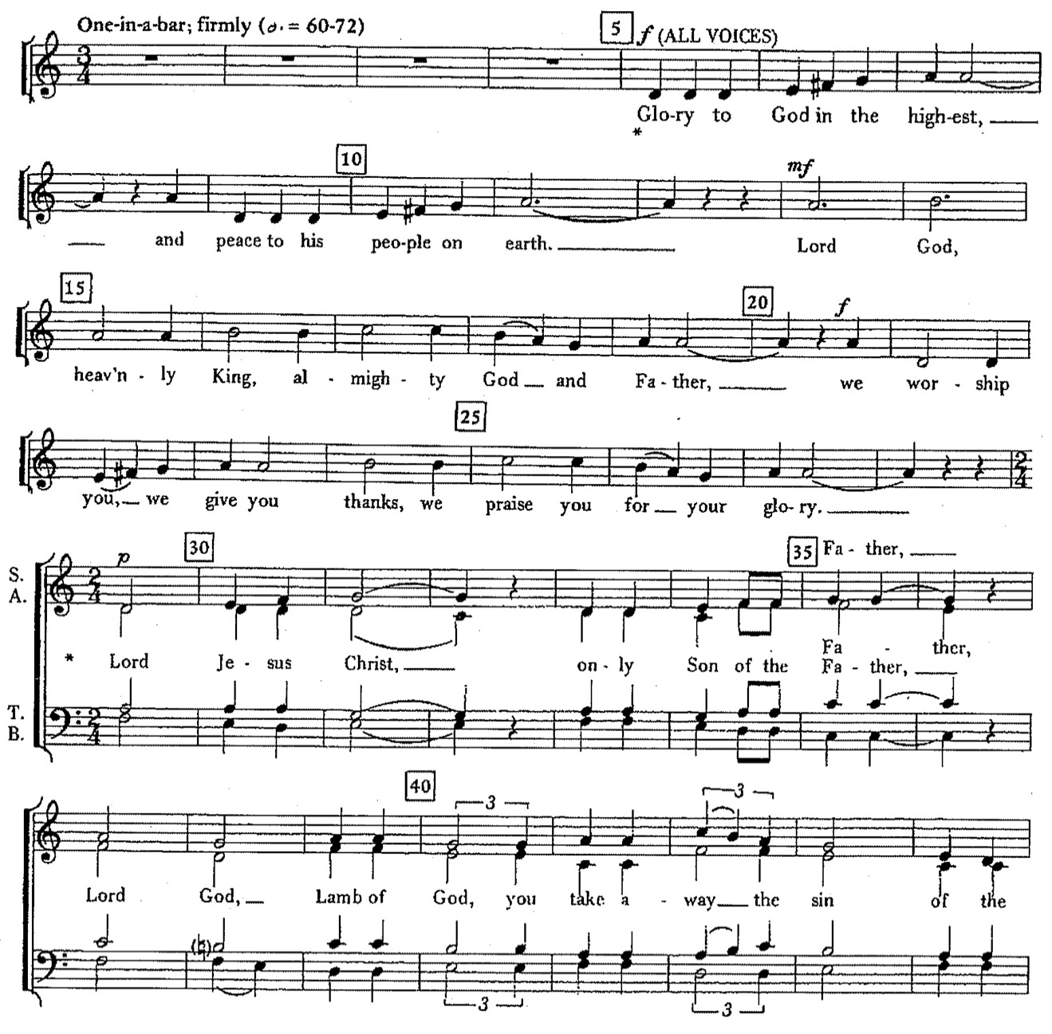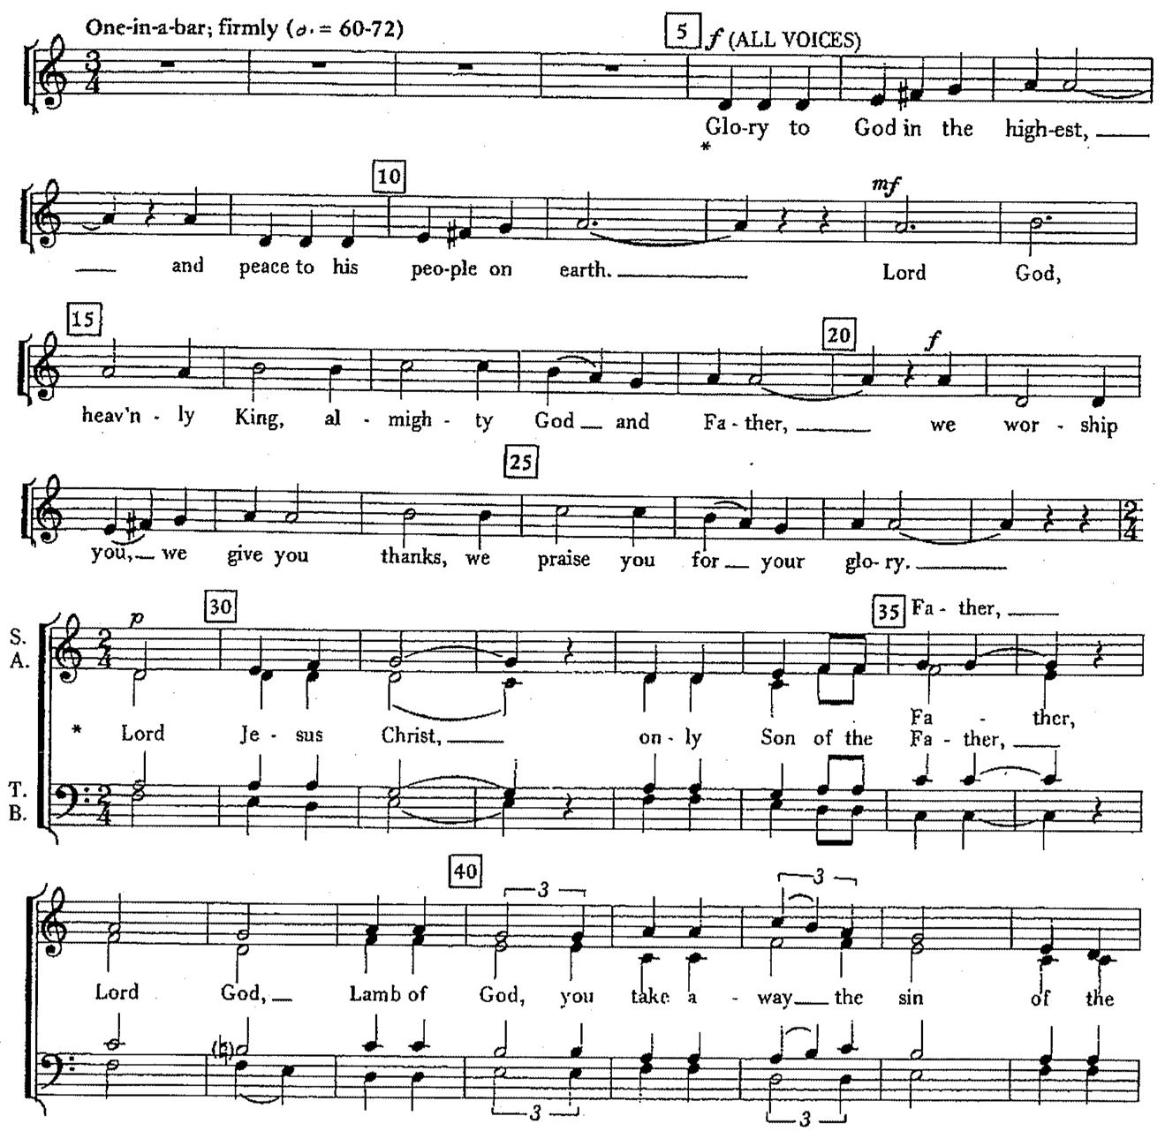

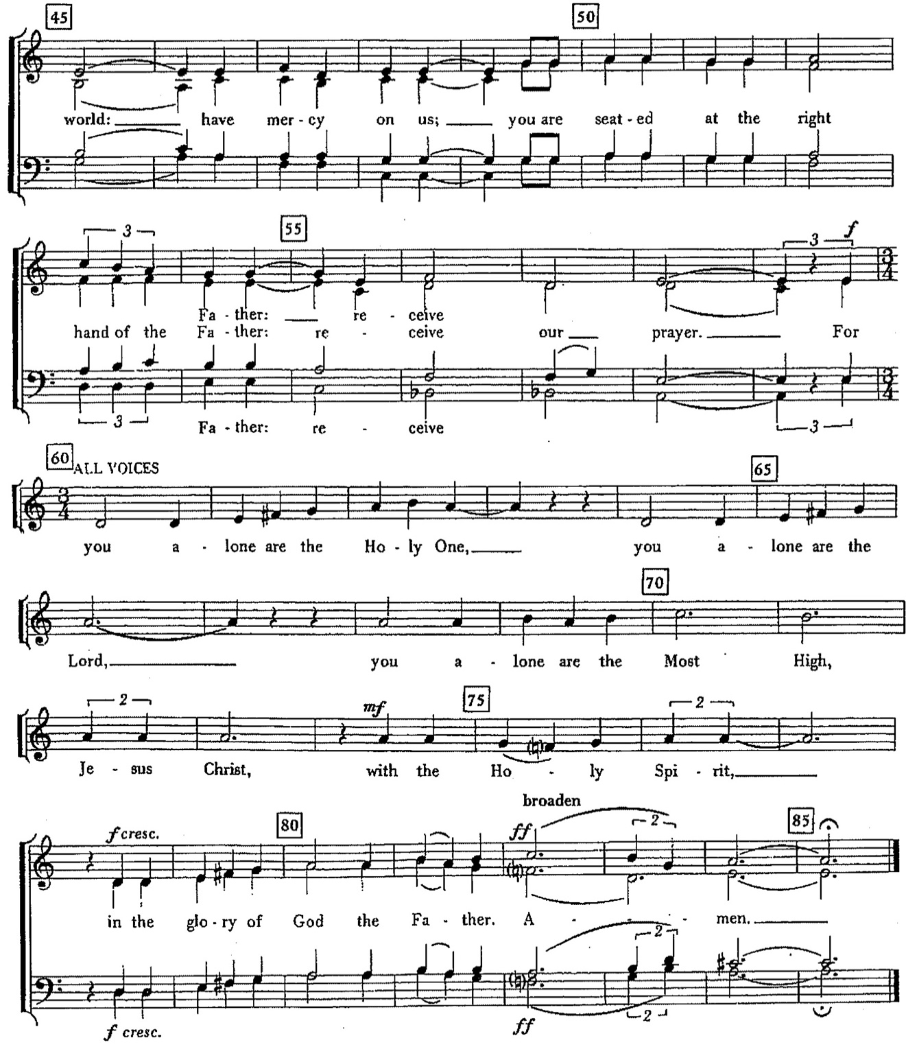

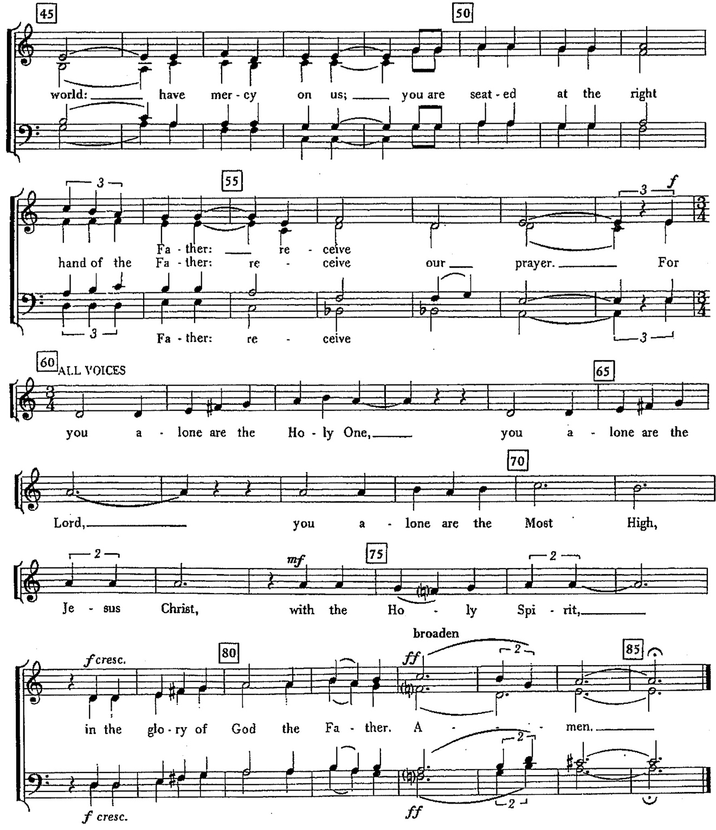

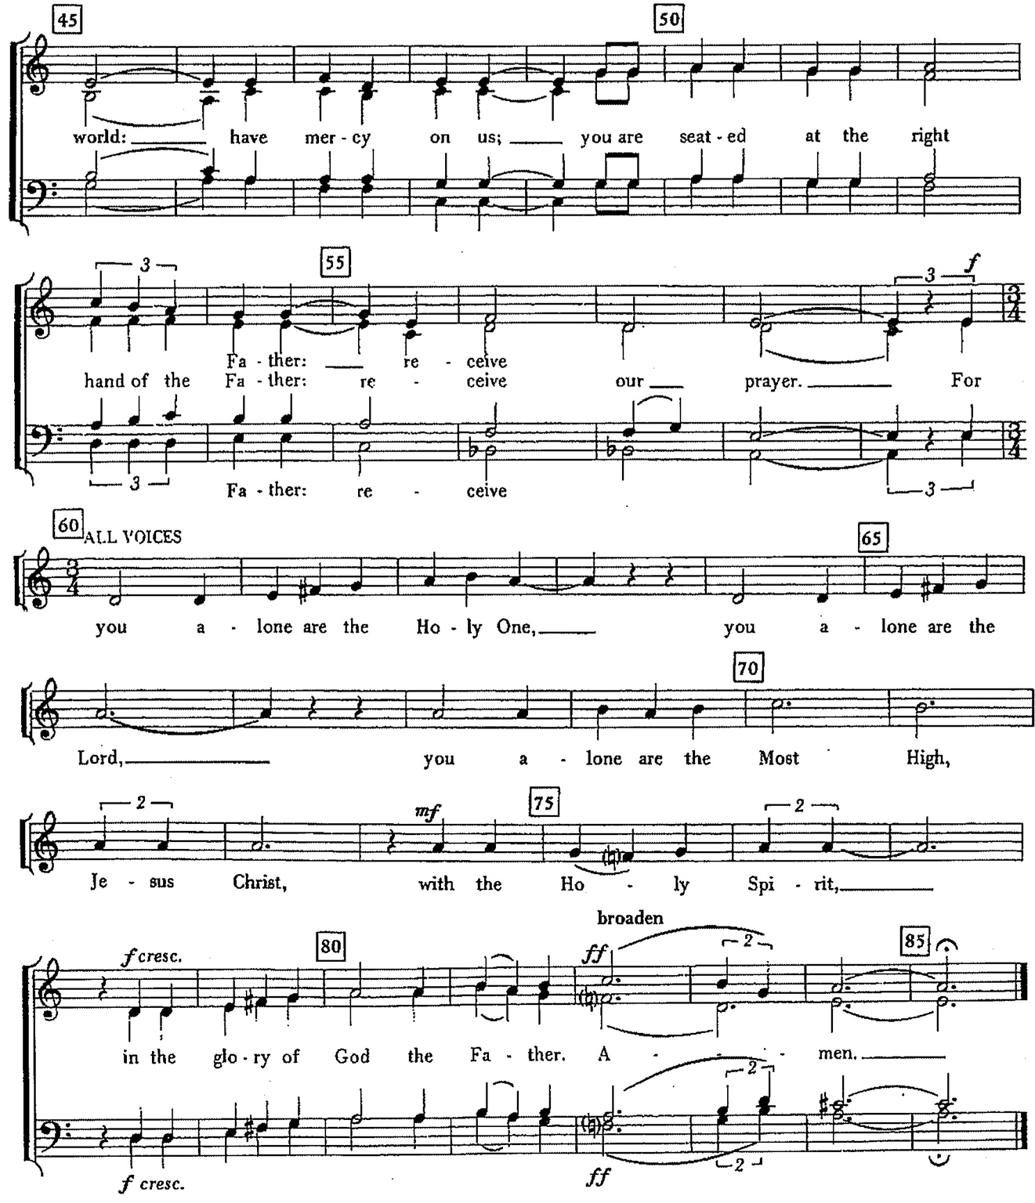

Music: from Communion Service (Series 3), John Rutter (b. 1945)

The Collect of the Day

The Celebrant says to the people
The Lord be with you.
People And also with you.
Celebrant Let us pray.
Almighty and everlasting God, who in the Paschal mystery established the new covenant of reconciliation: Grant that all who have been reborn into the fellowship of Christ's Body may show forth in their lives what they profess by their faith; through Jesus Christ our Lord, who lives and reigns with you and the Holy Spirit, one God, for ever and ever. Amen.
The Lessons

The people sit. One or two lessons, as appointed, are read, the Reader first saying

A Reading from the Acts of the Apostles (5:27-32)

When the temple police had brought the apostles, they had them stand before the council. The high priest questioned them, saying, "We gave you strict orders not to teach in this name, yet here you have filled Jerusalem with your teaching and you are determined to bring this man's blood on us." But Peter and the apostles answered, "We must obey God rather than any human authority. The God of our ancestors raised up Jesus, whom you had killed by hanging him on a tree. God exalted him at his right hand as Leader and Savior that he might give repentance to Israel and forgiveness of sins. And we are witnesses to these things, and so is the Holy Spirit whom God has given to those who obey him."

The Word of the Lord.
People Thanks be to God.

Silence may follow

Psalm 118:14-29

14 The Lord is my strength and my song, *
and he has become my salvation.

15 There is a sound of exultation and victory *
in the tents of the righteous:

16 "The right hand of the Lord has triumphed! *
the right hand of the Lord is exalted!
the right hand of the Lord has triumphed!"

17 I shall not die, but live, *
and declare the works of the Lord.

18 The Lord has punished me sorely, *
but he did not hand me over to death.

19 Open for me the gates of righteousness; *
will enter them;
I will offer thanks to the Lord.

20 "This is the gate of the Lord; *
he who is righteous may enter."

21 I will give thanks to you, for you answered me *
and have become my salvation.

22 The same stone which the builders rejected *
has become the chief cornerstone.

23 This is the Lord's doing, *
and it is marvelous in our eyes.

24 On this day the Lord has acted; *
we will rejoice and be glad in it.

25 Hosannah, Lord, hosannah! *
Lord, send us now success.

26 Blessed is he who comes in the name of the Lord; *
we bless you from the house of the Lord.

27 God is the Lord; he has shined upon us; *
form a procession with branches up to the horns of the altar.

28 "You are my God, and I will thank you; *
you are my God, and I will exalt you."

29 Give thanks to the Lord, for he is good; *
his mercy endures for ever.

Silence may follow.

A Reading from the Book of Revelation (1:4-8)
John to the seven churches that are in Asia: Grace to you and peace from him who is and who was and who is to come, and from the seven spirits who are before his throne, and from Jesus Christ, the faithful witness, the firstborn of the dead, and the ruler of the kings of the earth. To him who loves us and freed us from our sins by his blood, and made us to be a kingdom, priests serving his God and Father, to him be glory and dominion forever and ever. Amen. Look! He is coming with the clouds; every eye will see him, even those who pierced him; and on his account all the tribes of the earth will wail. So it is to be. Amen. "I am the Alpha and the Omega," says the Lord God, who is and who was and who is to come, the Almighty.

The Word of the Lord.
People Thanks be to God.

Silence may follow.

Hymnal 454 – When Jesus Came, adored by angels
Deacon The Holy Gospel of our Lord Jesus Christ
according to John (20:19-31)
People Glory to you, Lord Christ.

When it was evening on that day, the first day of the week, and the doors of the house where the disciples had met were locked for fear of the Jews, Jesus came and stood among them and said, "Peace be with you." After he said this, he showed them his hands and his side. Then the disciples rejoiced when they saw the Lord. Jesus said to them again, "Peace be with you. As the Father has sent me, so I send you." When he had said this, he breathed on them and said to them, "Receive the Holy Spirit. If you forgive the sins of any, they are forgiven them; if you retain the sins of any, they are retained." But Thomas (who was called the Twin), one of the twelve, was not with them when Jesus came. So the other disciples told him, "We have seen the Lord." But he said to them, "Unless I see the mark of the nails in his hands, and put my finger in the mark of the nails and my hand in his side, I will not believe." A week later his disciples were again in the house, and Thomas was with them. Although the doors were shut, Jesus came and stood among them and said, "Peace be with you." Then he said to Thomas, "Put your finger here and see my hands. Reach out your hand and put it in my side. Do not doubt but believe." Thomas answered him, "My Lord and my God!" Jesus said to him, "Have you believed because you have seen me? Blessed are those who have not seen and yet have come to believe." Now Jesus did many other signs in the presence of his disciples, which are not written in this book. But these are written so that you may come to believe that Jesus is the Messiah, the Son of God, and that through believing you may have life in his name.
After the Gospel, the Reader says
The Gospel of the Lord.
People Praise to you, Lord Christ.
The Sermon The Reverend Deacon Linda Potter
All standing
The Nicene Creed
We believe in one God,
the Father, the Almighty,
maker of heaven and earth,
of all that is, seen and unseen.
We believe in one Lord, Jesus Christ,
the only Son of God,
eternally begotten of the Father,
God from God, Light from Light,
true God from true God,
begotten, not made,
of one Being with the Father.
Through him all things were made.
For us and for our salvation
he came down from heaven:
by the power of the Holy Spirit
he became incarnate from the Virgin Mary,
and was made man.
For our sake he was crucified under Pontius Pilate;
he suffered death and was buried.
On the third day he rose again
in accordance with the Scriptures;
he ascended into heaven
and is seated at the right hand of the Father.
He will come again in glory to judge the living and the dead,
and his kingdom will have no end.
We believe in the Holy Spirit, the Lord, the giver of life,
who proceeds from the Father and the Son.
With the Father and the Son he is worshiped and glorified.
He has spoken through the Prophets.
We believe in one holy catholic and apostolic Church.
We acknowledge one baptism for the forgiveness of sins.
We look for the resurrection of the dead,
and the life of the world to come. Amen.
The Prayers of the People

Dear Lord, we thank and praise you for your glorious resurrection. You have taken away the sin of the world and shown us that your kingdom is eternal.

So we pray:
Risen Lord hear our prayer.

We pray for the church.

Enliven the church for its mission. Breathe fresh life into your people. Give us power to reveal Christ in word and action.

So we pray:
Risen Lord hear our prayer.

We pray for the world.

Inspire with your wisdom those who govern on this planet to commend themselves to renounce all forms of racism, injustice, and all legislative acts that deprive basic human rights to our brothers and sisters everywhere. Bring your peace to the world.

So we pray:
Risen Lord hear our prayer.

We pray for our community.

Uplift and continually energize all who are chosen and anointed as our earthly Shepherds of your word and will, and become the guiding beacons on our sacred path to you. We pray for Sean, our Presiding Bishop; Phil, our bishop; Mike, our priest; Linda our deacon; our vestry, and all those who support the mission of Christ Church.

In our diocesan cycle of prayer we pray for Christ Church; Anacortes; and
St. Paul, Bellingham.
In our parish cycle of prayer, for Marilee & Robert; Suzanne; Phillip;
Jen; Marion; Susan; and Deanna.

So we pray:
Risen Lord hear our prayer.

We pray for those who suffer and those in any trouble.

Your Son appeared to Mary Magdalene when she was weeping. Comfort those who are sick in body, mind or spirit, poor, oppressed, prisoners, sad, lonely, or grieving. May they know the power of your healing love.

So we pray:
Risen Lord hear our prayer.

We pray for the unity of all people.

Your Son met the women and asked them to tell the disciples about his resurrection. Guide Christians everywhere to witness to the resurrection in their lives.

So we pray:
Risen Lord hear our prayer.

We pray for those who do not know you.

Reveal yourself to us and all people through the teaching of your word and the celebration of your holy meal.

So we pray:
Risen Lord hear our prayer.

We pray for peace from above.

You strengthened the faith of Thomas by telling him to touch the hands and side of Jesus. Reassure those who are troubled by doubts, and strengthen their faith in your goodness.

So we pray:
Risen Lord hear our prayer.

We pray for the departed.

You conquered death and won the victory by resurrection. Be with those who have died, and those who are dying, and lead them to life with you forever. Give comfort to those who mourn.

So we pray:
Risen Lord hear our prayer.

The Celebrant adds this concluding collect.

Gracious God, as we reflect on Easter, may we carry your love and redemption in our hearts. Guide us in living out the Easter message daily and may the grace and glory of your resurrection fill the hearts of all. Amen.
The Peace

All stand. The Celebrant says to the people
The peace of the Lord be always with you.
People And also with you.

Then the Ministers and People may greet one another in the name of the Lord.
Offertory Hymn 206 – O Sons and Daughters
Doxology
The Great Thanksgiving – Eucharistic Prayer D
The people remain standing.
The Celebrant, whether bishop or priest, faces them and sings or says
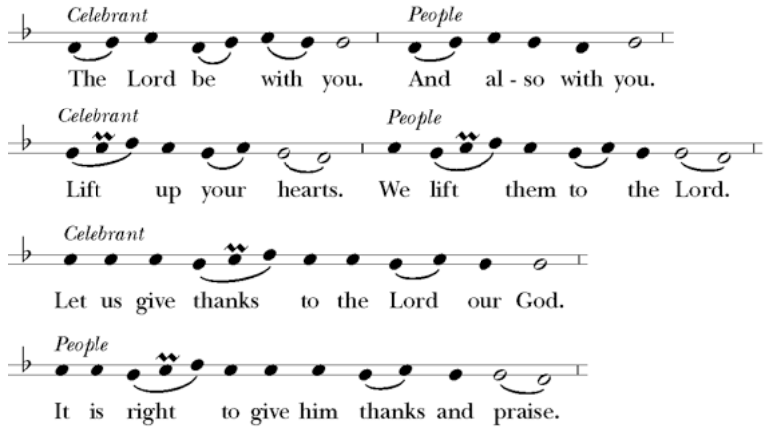

Then, facing the Holy Table, the Celebrant proceeds
It is truly right to glorify you, Father, and to give you thanks; for you alone are God, living and true, dwelling in light inaccessible from before time and for ever.
Fountain of life and source of all goodness, you made all things and fill them with your blessing; you created them to rejoice in the splendor of your radiance.
Countless throngs of angels stand before you to serve you night and day; and, beholding the glory of your presence, they offer you unceasing praise. Joining with them, and giving voice to every creature under heaven, we acclaim you, and glorify your Name, as we sing (say),

Celebrant and People
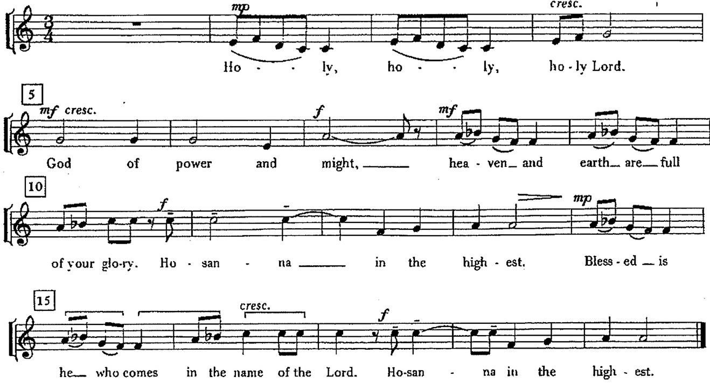

Music: from Communion Service (Series 3), John Rutter (b. 1945)
The Celebrant continues
We acclaim you, holy Lord, glorious in power. Your mighty works reveal your wisdom and love. You formed us in your own image, giving the whole world into our care, so that, in obedience to you, our Creator, we might rule and serve all your creatures. When our disobedience took us far from you, you did not abandon us to the power of death. In your mercy you came to our help, so that in seeking you we might find you. Again and again you called us into covenant with you, and through the prophets you taught us to hope for salvation.
Father, you loved the world so much that in the fullness of time you sent your only Son to be our Savior. Incarnate by the Holy Spirit, born of the Virgin Mary, he lived as one of us, yet without sin. To the poor he proclaimed the good news of salvation; to prisoners, freedom; to the sorrowful, joy. To fulfill your purpose he gave himself up to death; and, rising from the grave, destroyed death, and made the whole creation new.
And, that we might live no longer for ourselves, but for him who died and rose for us, he sent the Holy Spirit, his own first gift for those who believe, to complete his work in the world, and to bring to fulfillment the sanctification of all.
At the following words concerning the bread, the Celebrant is to hold it, or lay a hand upon it; and at the words concerning the cup, to hold or place a hand upon the cup and any other vessel containing wine to be consecrated.

When the hour had come for him to be glorified by you, his heavenly Father, having loved his own who were in the world, he loved them to the end; at supper with them he took bread, and when he had given thanks to you, he broke it, and gave it to his disciples, and said, "Take, eat: This is my Body, which is given for you. Do this for the remembrance of me."

After supper he took the cup of wine; and when he had given thanks, he gave it to them, and said, "Drink this, all of you: This is my Blood of the new Covenant, which is shed for you and for many for the forgiveness of sins. Whenever you drink it, do this for the remembrance of me."

Father, we now celebrate this memorial of our redemption. Recalling Christ's death and his descent among the dead, proclaiming his resurrection and ascension to your right hand, awaiting his coming in glory; and offering to you, from the gifts you have given us, this bread and this cup, we praise you and we bless you.

Celebrant and People

We praise you,
we bless you,
we give thanks to you,
and we pray to you, Lord our God.

The Celebrant continues

Lord, we pray that in your goodness and mercy your Holy Spirit may descend upon us, and upon these gifts, sanctifying them and showing them to be holy gifts for your holy people, the bread of life and the cup of salvation, the Body and Blood of your Son Jesus Christ.

Grant that all who share this bread and cup may become one body and one spirit, a living sacrifice in Christ, to the praise of your Name.

Remember, Lord, your one holy catholic and apostolic Church, redeemed by the blood of your Christ. Reveal its unity, guard its faith, and preserve it in peace.

And grant that we may find our inheritance with the Blessed Virgin Mary, with patriarchs, prophets, apostles, and martyrs, and all the saints who have found favor with you in ages past. We praise you in union with them and give you glory through your Son Jesus Christ our Lord.

Through Christ, and with Christ, and in Christ, all honor and glory are yours, Almighty God and Father, in the unity of the Holy Spirit, for ever and ever.

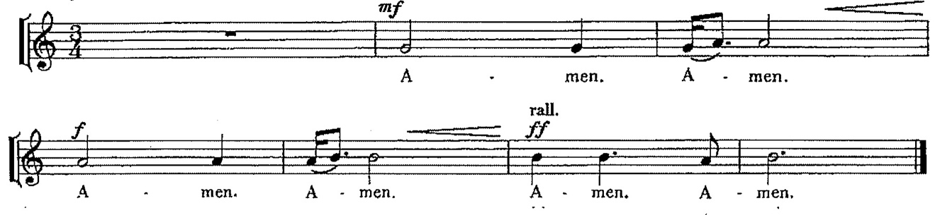
Music: from Communion Service (Series 3), John Rutter (b. 1945)
Celebrant
As our Savior Christ
has taught us,
we now pray,
People and Celebrant
Our Father in heaven,
hallowed be your Name,
your kingdom come,
your will be done,
on earth as in heaven.
Give us today our daily bread.
And forgive us our sins
as we forgive those
who sin against us.
Save us from the time of trial,
and deliver us from evil.
For the kingdom, the power,
and the glory, are yours.
now and for ever. Amen.
The Breaking of the Bread

The Celebrant breaks the consecrated Bread. A period of silence is kept.

Then may be sung or said

Celebrant
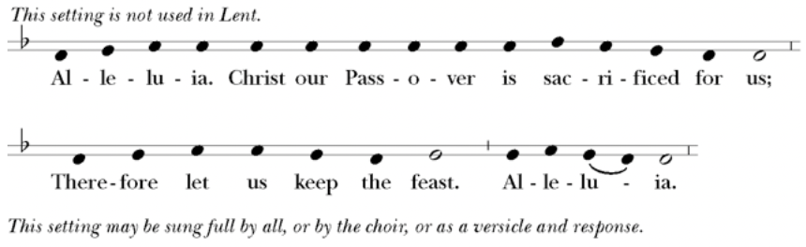
People
Music: Ambrosian chant; adapt. Mason Martens (1933-1991)

Facing the people, the Celebrant says the following Invitation

The Gifts of God for the People of God.
and may add Take them in remembrance that Christ died for
you, and feed on him in your hearts by faith,
with thanksgiving.

The Bread and Wine are given to the communicants with these words

The Body of Christ, the bread of heaven. [Amen.]
The Blood of Christ, the cup of salvation. [Amen.]
Hymnal 327 –Draw Nigh
After communion the Celebrant says
Let us pray.

Celebrant and People
Eternal God, heavenly Father,
you have graciously accepted us as living members
of your Son our Savior Jesus Christ,
and you have fed us with spiritual food
in the Sacrament of his Body and Blood.
Send us now into the world in peace,
and grant us strength and courage
to love and serve you
with gladness and singleness of heart;
through Christ our Lord. Amen.
The Bishop when present, or the Priest, may bless the people.

Hymnal 441 – In the Cross
Deacon Go in peace to love and serve the Lord. Alleluia. Alleluia.
People Thanks be to God. Alleluia. Alleluia.
Postlude
Announcements
Flowers for this Sunday
Flowers today are given by Terry Grundy to the Glory of God in celebration of her daughter Ashley Andersen’s birthday.
Forward Day-by-Day Available
The new May, June, July Day-by-Day are available at the kiosk in the Parish Hall. A $1.00 donation is suggested.
New Church Directories Available
Church directories have been updated and are available on the welcome table at the church entrance. Pick one up! If there are corrections to be made, please notify the church office at office@episcopallup.com
Christ Church Operating Budget 2025 Available
The Vestry approved church operating budget for 2025 is now available. Copies can be found on the welcome table at the church entrance.
Thank you to the Palm Sunday Readers
Deacon Linda
Passion readers at 8 am were Kay F., Melinda J., Lynn S., Roddi B., Susan M., Carly M., John H., Mikhal R., and John S.
Our 10 am Passion readers were Rolin S., Jeremy D., Sue G., Sandi C., Debra P., Tiffany R., Shelly F., Steve A., and Zibby S.
Thank you, readers, for bringing this Passion alive to us.
Flower Donations For Easter
Thank you to everyone who donated to flowers and plants for Easter. Remembrances and Thanksgivings were inserted into the Easter Sunday Bulletins. Many different varieties of plants were purchased - Lilies, Hydrangea plants, Azalea plants, Calla Lilies and perennials. All the plants were placed in the sanctuary. At the Vigil, and on Easter day, there was a true “explosion of flowers,” representing new life and “light.” The idea was to create a space where a person of faith or a visitor walks into church “and says, ‘How beautiful it is to be here.’ It was welcoming and the flowers help do that. As part of our care for creation, in a few weeks, all the potted plants will be planted outside in the grounds of Christ Church. The plants will live on.
Thank you to the Altar Guild, Diana Mears and Deacon Linda for arranging the flowers. Thank you to Lisa Chatterton who will plant the plants outside. Christ Church was beautifully decorated for Easter
A Big Easter Thank You to The Volunteers
Deacon Linda
This year during Holy Week, I was especially mindful of the number of dedicated volunteers who freely gave their time and talents to make worship at Christ Church happen. As we remembered our Lord’s death and celebrated his resurrection, volunteer efforts were essential in helping everything run smoothly to make these powerful events present in our lives once again.
Thank you to everyone who helped make Holy Week and Easter so special. To the Altar Guild who prepared the altar, made sure all was ready for every service of Holy Week and Easter Sunday and who performed many extra duties; those who prepared, provided food, and helped set up and clean up at the Maundy Thursday Agape meal; to the Ushers, who handed out bulletins and found seats for latecomers; to the Offering counters; those who coordinated ordering and picking up Easter Lilies, Tulips, and other potted flowers and set them up; to our musician Vicki M. for the beautiful music she provided during Holy Week and Easter Sunday; to our Acolytes who served at all the Holy Week and Easter Sunday services ; to our readers who read lessons at every service; to our Eucharistic Ministers who served the chalice; to the greeters; to our Thurifer, Rolin S.; to Nancy N. who printed all the bulletins for Holy Week and to the office volunteers who helped Nancy N.; to Lisa and Paul C. for cutting and trimming the grass; to those who provided refreshments at the Coffee Hours; to our clergy Fr. Mike, and Deacon Linda for serving at no less than 8 services in one week; and all those who served in other ways. All of you met the spiritual needs of our parishioners and visitors who came to Christ Church.
Thank you also to Zibby S., Diana M., Nancy N., and Deacon Linda for creating the Meditation space in the parish hall for anyone who wanted a prayerful space to pray.
As we continue in this great season of Easter, thank you for your active participation in our Holy Week liturgies. By your active participation, you have truly made the celebration of the resurrection of Christ a joyful and holy one.
Cathedral Day 2025
May 3, 8:30 am – 2:00 pm | Saint Mark's Cathedral, Seattle
Cathedral Day is a “family reunion” for Episcopalians from across western Washington. It’s a time for connecting across congregations and experiencing all your cathedral has to offer. Cathedral Day celebrates the idea of pilgrimage, with Saint Mark’s serving as your sacred destination. We can’t wait to welcome you to YOUR cathedral!
Fellowship Book Group
Please join us for fellowship and lively discussion. We start with fellowship at 6:00 pm and discussion starts at 6:30 pm. We’d love to have you join us.
The next meeting will be on our usual meeting day, (4th Monday of the month) April 28, 2025, via zoom.
The Zoom link and passcode are:
Meeting ID: 82826550583
Passcode: 121698
The book for April will be Holy Grounds - The Surprising Connection between Coffee and Faith -- From Dancing Goats to Satan's Drink by Tim Schenck (We are not finding it in the library system, Audible or Libby - mainly ordering through various secondhand book sellers).
In Holy Grounds, Schenck explores the relationship between coffee and religion, moving from faith-based legends that have become entwined with the history of coffee to personal narrative. He takes readers on a journey through coffee farms in Central America, a pilgrimage to Seattle, coffeehouses in Rome, and a monastic community in Pennsylvania.
New this year, we are providing the title of the book chosen for the next month, so readers will have time to get on library wait lists or plan for any ordering backlog. The book for May will be:
"The Irresistible Blueberry Bakeshop and Cafe' " by Mary Simses.
Questions? Speak with any of the following: Shelly Fairbanks, DeeDee Fournier, Sandi Carter, Jen Killion, Melinda Jackson
Puyallup Food Bank Donations
Happy April!
First - A Great Big Thank You for the can openers! Melinda J. donated 50 can openers to the Food bank. With the larger size handles and turning knob, they should be easier for those with arthritis to use. 🙂
Next, now that warmer weather is within sight and new life is springing, a few ideas for the Food Bank:
- Facial tissues. Plants blooming can bring allergies
- Diapers, toddler training underwear such as pull-ups and while we're on the subject of paper
- Paper towels | - Baby wipes
- Toilet paper
Of course, anything that is shelf stable that you think of and would like to donate is welcome!
Thank you all for your support of our friends and neighbors!!
Judy Hansen, Vestry Outreach
Soup Kitchen
Susan Myers and Deacon Linda
Thank you to Maria H. for providing soup, Jean H. for providing bread, Steve A. for providing fruit, and Susan M. for providing dessert. For Steve A. & Calvin S. for serving food, Maria H. & Susan M. for helping in the kitchen, and Lynn S. and Sandra C. for volunteering at the Hospitality Table.
This week's totals:

Guests served: 18
Bus passes given out: 22
Laundry Packets: 16
How many picked up mail: 7
Toiletries given out: 16
Socks: 12

Hospitality/Toiletry Items Needed:
- Shampoo
- Body Lotion
Thank you for your kindness in helping others.
Zimzum Discipleship Invitation from the Bishop
Practices for a Christ-Center Life
Join us on our new three-year discipleship series on zimzum discipleship, of intentionally making space to live as a faithful apprentice of Jesus. For more information and resources please access the diocese website: ecww.org.
Underhill House Virtual Open House Invitation
Sunday, April 27, 4:00-5:00 pm | Zoom
Blessed Lent to you. Hopefully, you’ve been inspired by the quiet, meditative quality of the season to engage in contemplative practices that welcome your introspective intention and hold you in deep connection with Spirit. Many of us initially began our devotion to contemplative practices having discovered them either during Lent or Advent. Some found continuing these practices during the liminal feast days of Easter and Christmas helped to hold the tenderness and wisdom of these seasons with a richer, more personal resonance.
In this spirit, Underhill House invites you to a virtual Open House to introduce you to the esteemed contemplative and spiritual guide, Evelyn Underhill, as well as to the history of the organization and the practice she inspired. You may find this is a practice you want to personally incorporate into your weekly routine by visiting their Capitol Hill location, or maybe one fitting your church or other spiritual community.
Questions? Email Phil Rose at phil@underhillhouse.org.
Memorial Day Weekend at Huston
Saturday-Monday, May 24-26, 2025
Let Huston Camp & Conference Center be a launch pad for your Memorial Day weekend.
Looking for a meditative weekend in the woods along a river? Or a home-base for your own fun with family or friends? Itchin’ to get out on the trails at Huston and Wallace Falls State Park? We'll provide Huston hospitality: cozy rooms, yummy food and a beautiful location.
You create your own agenda of fun, adventure and memories.
Come and go as you desire throughout the weekend.
Check-in is available as early as 9AM Saturday. Final check-out is 11AM Monday. Meal service begins with Lunch on Saturday (12:30pm) and ends with Breakfast on Sunday (8:00am).
Stay for one night or two. Come just for the day (either Saturday or Sunday). Flat rates are the same for Upper or Lower Camp. Half price rates for children 3-11. (Minors must be accompanied by an adult.)
To register use QR code,

or go to www.huston.org/events
Call or Email: 360-793-0441 | info@huston.org

Sermon Notes
Today’s Ministers of Worship

Celebrant: The Rev. Mike Mayor
Deacon: The Rev. Linda Potter
Lectors: Brian Davidek, Jeremy Duplissey
Acolyte: Brian Davidek
Eucharistic Minister: Christine Scholer
Livestream Coordinator: Bonnie Quintana
Pianist: Vicki Melton
Greeters: Carla Golden, DeeDee Fournier, Helen Godwin, Tiffany Richards, Christine Scholer
Usher: Tanya Elder
Closer: Jane Beck
Altar Guild: Cindy Johnson, Susan Myers, Christine Scholer, Jean Irey

Music permission through OneLicense #A-706918


Scan to give online. All payments are processed through Paypal.

Christ Episcopal Church
A congregation of the Episcopal Diocese of Olympia
Bishop – The Rt. Rev. Philip N. LaBelle
Rector – The Rev. Mike Mayor
Vestry
Sr. Warden – Shelly Fairbanks
Jr. Warden for Property – Jeremy Duplissey
Jr. Warden for Communication – Nancy Nesheim
Treasurer – Melinda Jackson
Clerk – Tanya Elder
Member – Maria Haack
Member – Judy Hansen
Member – Kathy Mason
Member – Susan Myers
Member – David Steere
Member – Rolin Stone
210 5th St. SW | Puyallup, WA | 98371
253-848-2323 | office@episcopallup.com
www.episcopallup.com

